Enterprise Structure
What is enterprise structure and why it is needed?
The enterprise structure represents the business structure in the real world.
This organizational data reflects the structure of your business. It is subdivided into various organizational units which, for legal reasons or business-related reasons, are grouped together.
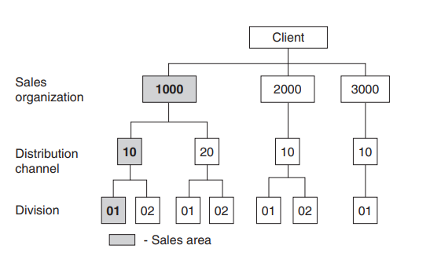
Sales Organization : An organizational unit that sells and distributes products.
SAP Customizing Implementation Guide | Enterprise Structure | Definition | Sales and Distribution | Define, Copy, Delete, Check Sales Organization
Table : V_TVKO
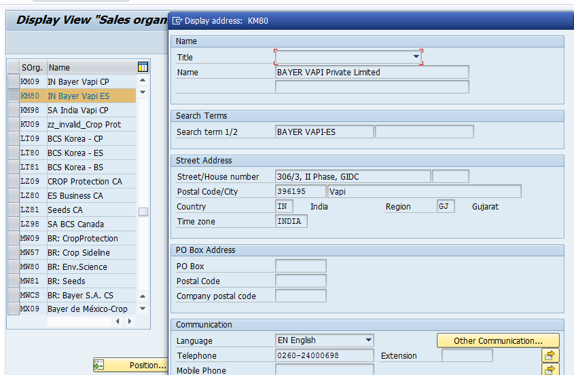
Example: Sales Org is VAPI India and all others are details

A Distribution Channel : The channel through which materials or services reach customers. Typical distribution channels include Internet sales, wholesale, retail, and direct sales.
SAP Customizing Implementation Guide | Enterprise Structure | Definition | Sales and Distribution | Define, Copy, Delete, Check Distribution Channel
Table :V_TVTW
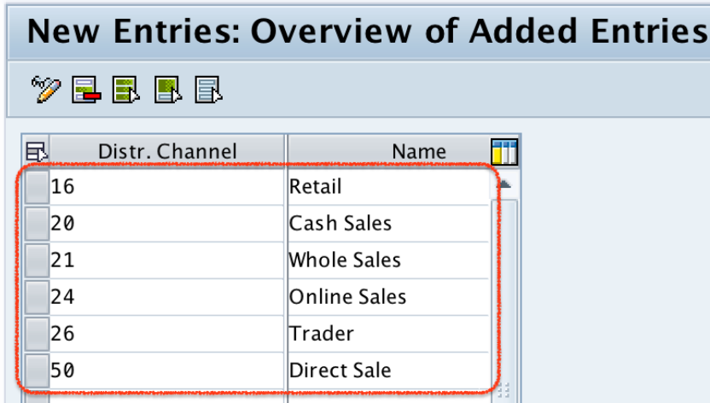
Example: Suppose the product is laptop then company will sell the laptops via channel cash sale, whole sale etc.
Division: It is group of products. Materials or products always belong to one division
SPRO -> SAP IMG -> Enterprise Structure –> Definition –> Logistics -General -> Define copy, delete, check division
Table :V_TSPA
Examples: Vegetables, seeds, fertilizers.
There are the three different products hence division cant be the same.
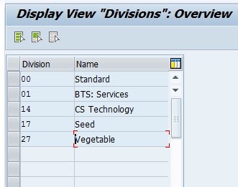
Sales Office: Sales Office is an organizational unit which can use as a branch. Companies often set up several sales offices apart from the head office or headquarters to reach the market in depth
Menu Path SAP Customizing Implementation Guide | Enterprise Structure | Definition | Sales and Distribution | Maintain Sales Office
Example: Suppose, Main Company is at Mumbai but most selling is there in Nashik then that company will create the sales office you can all it as a branch at Nashik and that office will take care of all the selling take place at Nashik or near about districts or even the small villages.
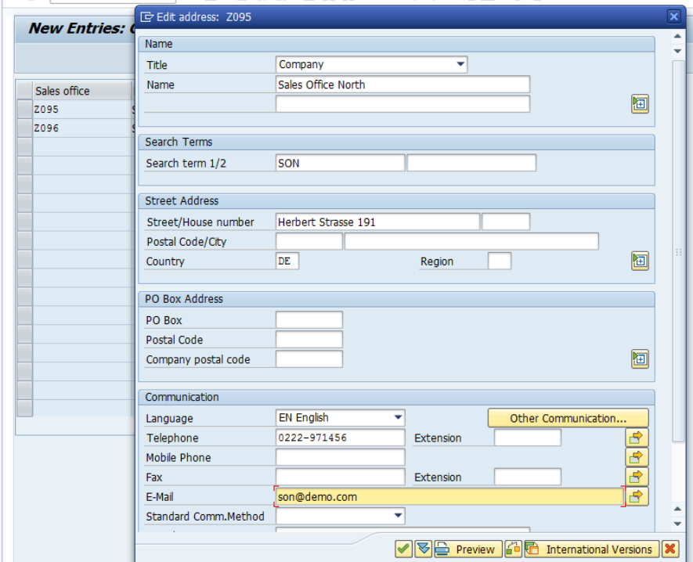
Sales Group : The staff of a sales office may be subdivided into sales groups. For example, sales groups can be defined for individual divisions within the sales team.
SAP Customizing Implementation Guide | Enterprise Structure | Definition | Sales and Distribution | Maintain Sales Group
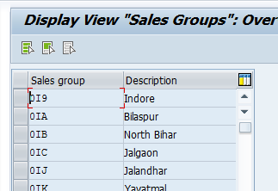
Example: Suppose sales office is at Mumbai, and most of the orders are coming from Indore, Jalgaon then you can create the sales group likewise.
Salespersons : Individual personnel master records are used to manage data about salespersons. You can assign a salesperson to a sales group in the personnel master record. Sales offices and sales groups are optional organizational elements; you do not need to configure them if you have no use for them. In this case, make sure that the sales office and sales group fields are not marked as mandatory on the customer master or the order entry screens. Otherwise, the users will be required to enter a value that you have not maintained
Company: Company is the smallest organizational unit. For complete business structure you can create the enterprise structure ahead.
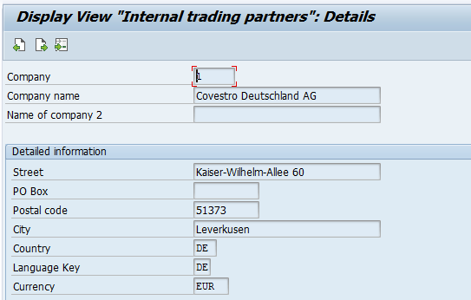
Company code:
Company Code is a smallest organizational unit used to represent the company for external accounting.
So the company codes which is used to represented the company that will take care of their own accounting.
A company can include either one or more company codes
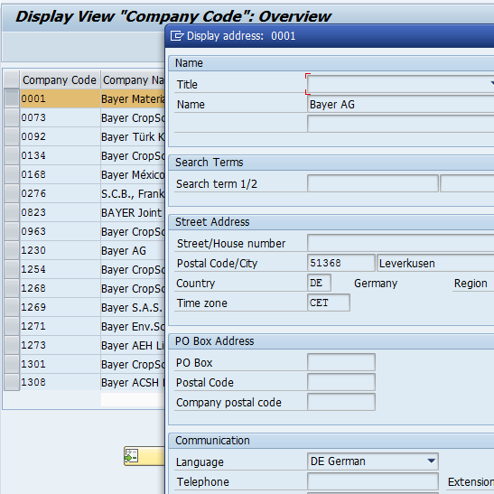

Plant: A plant is a logistics organizational unit where materials are produced or goods and services are provided. It is where production, procurement, and materials planning are executed. A material may exist within more than one plant. Also, stock is delivered to a customer from a plant, the availability check is carried out in a plant.

Plant Determination
- CMIR
- Customer Mater
- Material Master
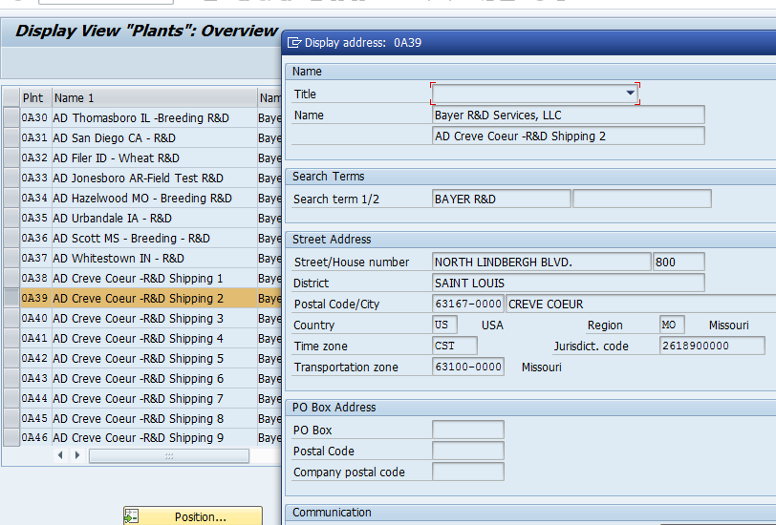
A storage location defines a storage area for the stock in a plant. One or more plants are assigned to a company code. And one or more storage locations are assigned to a plant.
• A plant can only exist within one company code.
• A plant may be assigned to more than one combination of sales organization and distribution channel. So you may sell stock from the same plant into different sales areas.
• A plant may have more than one shipping point. (A shipping point may also be assigned to more than one plant.)

Shipping Point : The physical location (for example, a warehouse) from which you ship the item.
A shipping point is assigned to one or more plants and can be divided into several loading points.
During delivery processing, the shipping/receiving point is the most important criterion that you use to select deliveries.
A delivery can be shipped from one shipping point only or received at one receiving point
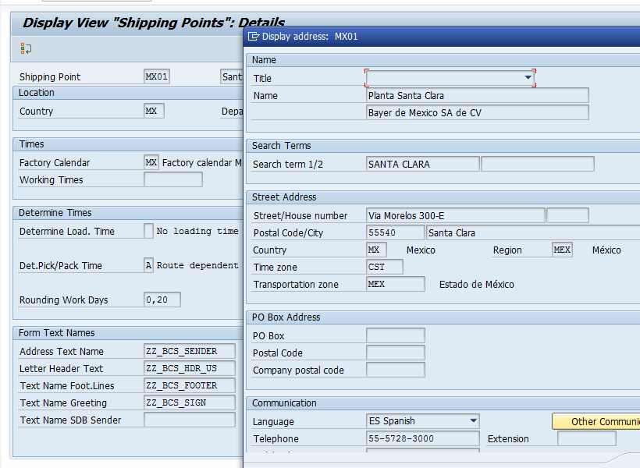
Shipping data are determined based on:
- loading group in material master sales view,
- Shipping Conditions in customer master sales data shipping view.
- Plant

Maintain storage location

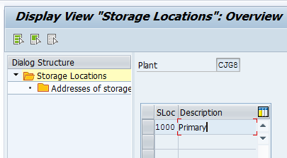

A storage location is the place where stock is physically kept within a plant.
A storage location has the following attributes:
- There may be one or more storage locations within a plant.
- Stocks are managed only on a quantity basis and not on a value basis at storage location level.
- Physical inventories are carried out at storage location level.
- Storage locations are always created for a plant.
Storage location determination:
- Plant + Shipping point + Storage condition

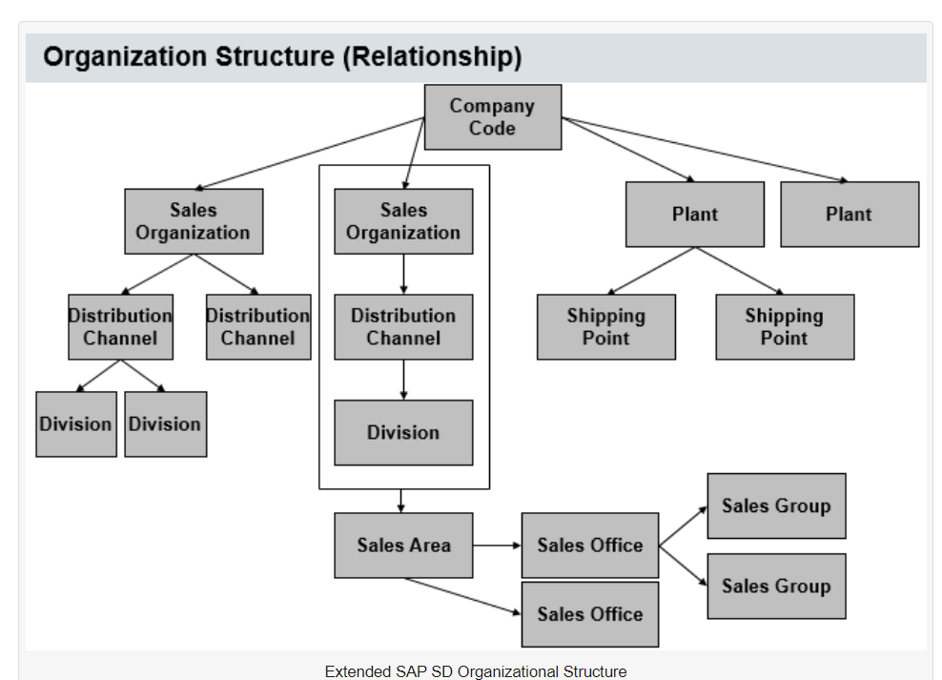

- Multiple sales organization can be assigned to one company code.
- The relationship between Sales Organization and Distribution Channel is Many-to-Many.
- The relationship between Sales Organization and Division is Many-to-Many.
- Company code may have many plants. Plant can be assigned to only one company code.
- The relationship between Plant and Shipping Point is Many-to-Many.
- Plant can be divided into several storage location but one storage location can be assigned to only one plant.
- Materials or products always belong to one division
Shipping Point Determination: (Tcode- OVL2, Table-TVST)
- Shipping Condition- Customer Master (shipping tab)-as soon as possible
- Loading Group -Material master record(Sales/plant)- Crane
- Plant- Customer Master/ Material master record
Item Category:
An item category is used to define if an item is suitable for billing or pricing. It defines the additional control functions for a sales document.
Example − A standard item function is totally different from the function of a free of charge item or a text item.
As per the sales document type, you can define different types of item categories. If required, you can also modify the existing item categories or can also define new item categories.

Categorization | Description of an Item
TAN | Standard Item
TAB | Individual Purchase Order
TAS | Third Party Item
TAD | Service
TANN | Free of charge item
TATX | Text item
AFX | Inquiry item
AGX | Quotation item

To create an Item category − T-Code: VOV7
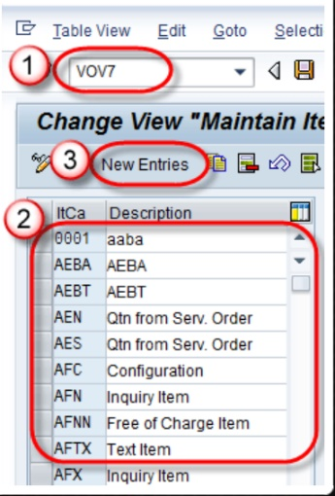

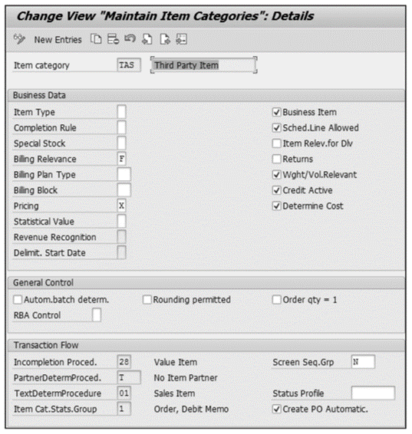

Item Type: This field determines how the items need to be classified. Whether it’s a blank-standard item, A (value item), B (text item), C (packing item)
Completion Rule: This field determines whether the quotation or sales contract is complete or not. As per full qty, value, target quantity, contract release
Special Stock: The stock managed separately and not owned by the company are called special stock. It is used in case of process like consignment and MTO.
Billing Relevance: This field specify how the billing needs to be performed on the line items. Such as- Order related billing, delivery related billing or no billing has to be performed.
Billing Plan Type: We can bill the customer as per predefined billing plan. Whether its milestone billing or periodic billing.
Billing Block: The system won’t be able to create the billing for the line item if the billing block has been set for the particular line item in the sales document. You can default the billing block during sales document creation in the line item if you assign the billing block in the item category configuration. You can set the billing block at the header level as well.
Pricing: It controls line item in delivery is relevant for pricing or not.
Blank- Not relevant for pricing, X- standard pricing, B- Free goods.
Statistical Value: For certain business scenarios, such as BOMs, the requirement is to have the pricing at the line-item level instead of header pricing. To achieve the requirement, you have to set the item category associated with the main item as a statistical value. This won’t update the line-item value, but will be used as the statistical value.
Business Item: Indicates whether, during sales order processing, the business data that you enter for an item is allowed to be changed.
Sched.Line Allowed: You can check the field schedule to determine the schedule lines in the sales order. The schedule lines will be allowed for all the delivery-relevant item categories. For order-related billing, the item categories associated with order-relevant billing won’t have this checkbox checked.
Item Relev.for Dlv: It controls item is relevant for delivery or not.
Returns: The checkbox controls the accounting entries when the billing has been created for the order. The checkbox is activated for the return process as well as for the credit memo process.
Wght/Vol.Relevant: In business scenarios where the routes are determined based on the weight of the line items. Activating the checkbox system calculates the weight and volume of the line item.
Credit Active: To update the line items in credit management, one of the prerequisites is to select this checkbox in the item category. Credit Active checkbox is unchecked are quotation, returns, consignments, cash sales, and credit memos.
Determine Cost: This checkbox is a prerequisite to determining the cost condition types in the pricing procedure. The cost condition types are EK01 and VPRS.
Autom.batch determ: The checkbox allows the system to automatically determine the batch for the sales order line item.
Rounding permitted: You can allow the system to do the rounding for the quantities in the sales order line item.
Incompletion Proced: The incompletion procedure consists of a list of mandatory fields that the user must fill in when creating a sales document. If any of the mandatory fields are missing, then system will not allow to save the sales document.
PartnerDeterm.Proced: You can specify the partner functions that are allowed for the line items by configuring the appropriate partner determination procedure via Transaction VOPAN and assigning it to the item category.
TextDeterm.Procedure: In business scenarios, item specific instructions or requirements that need to be passed to the organization. you can use the text determination functionality to achieve these requirements. The text procedure that you configure can be assigned to the item category.
Screen Seq.Grp: We can control the look and feel of transactions with the help of the screen sequence group. We need help from an ABAP consultant to perform the changes in the screen sequence group.
Create PO Automatic: This check create the automatic purchase order with respect to the purchase requisition in a third-party sales scenario.
Determined Item category − T-Code: VOV4

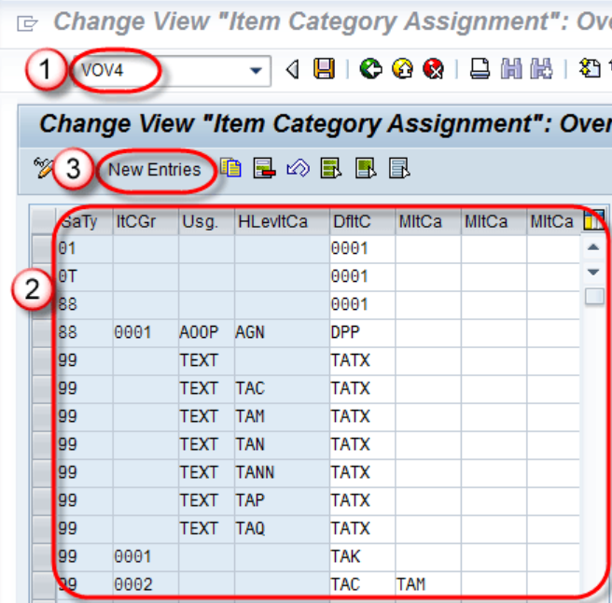

Sales Document type : As per the sales document type, you can define different types of item categories. Like for return order, credit and debit memo order type is different and hence the item category. For ex. there may be possibility item is not relevant for billing or pricing in the sales document and according to that need to define the item category.
Item Category Group: Material grouping that helps system to determine item category during sales document processing.
Define in material master
ERLA: structure material above
LUMF: structure material below
BANS: Third Party Item
NORM : Standard Order
Usage : The usage defines the conditions under which a material is sold. It can be entered at item or header level. Entries made at header level are valid for all items. System considers item usage for the below scenarios: - i) Whenever sub item is automatically determining into sales document other than BOM. Ex. - Free goods, material determination, cross selling and Batch split.
II) System considers item usage if we want to determine different item category for the same combination of document type + item category group
Define in Sales order header and item
Free goods usage is “FREE” Material determination usage is “PSHP” – for header item Material determination usage is “PSEL” – for sub item Material determination usage is “PSA1” – for item pricing Material determination usage is “PSA2” – for sub item Cross selling usage is “CSEL” Batch split usage is “CHSP”
Higher level Item :

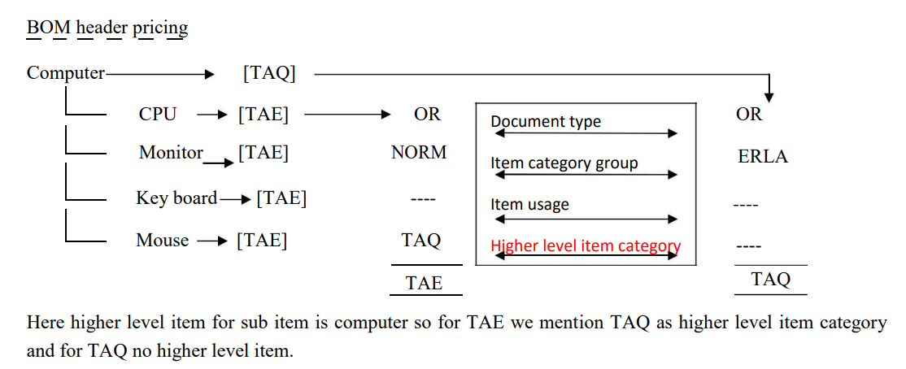
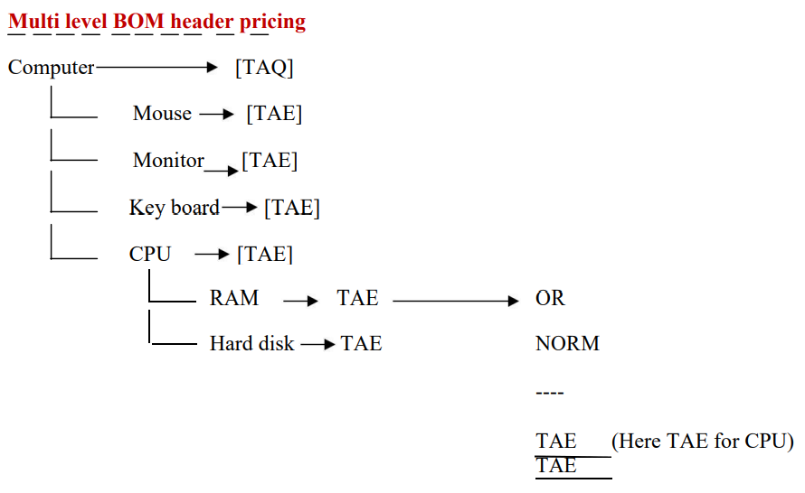
Sales Document Type :
Sales document type by which system process different documents in different way.
The Sales Order is an important and essential element in SD related activities. In the business scenario all the Deliveries and billing can be done with reference to a sales document only. SAP system provides different types of sales document
- Credit Memo Request
- Debit Memo request
- Standard Order
- Returns etc.
Create Internal No. Range for sales document type.
VN01 is T- code for creation for Internal No. range. We will use this internal no. in step-3.
- Enter T-code VN01 in command field in a new sap session.
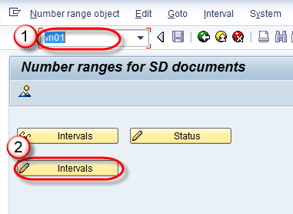
- Click on Create button for interval .

- Click on +Interval Button to create new interval range.
- Enter From number / To number / current number / leave blank Ext which stands for External Number Range.
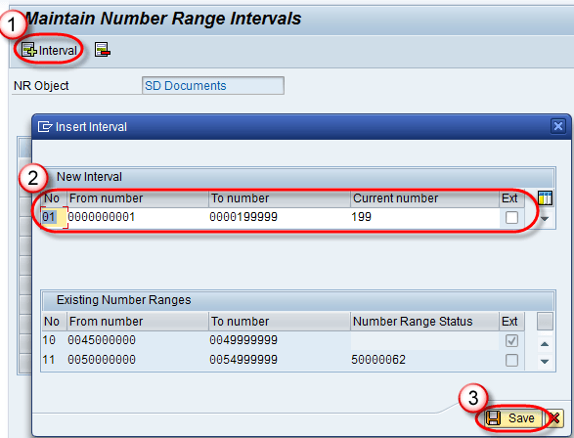
- Click on save button.

A Message "The changes were saved" is display.
Most used sales document type :
- IN – Inquiry
- QT – Quotation
- OR – Standard Order
- RE – Returns Order
- CR – Credit Memo Request
- DR – Debit Memo Request
- LF – Outbound Delivery Document
- LR – Returns Delivery
- F2 – Sales Invoice
- G2 – Credit Memo
- L2 – Debit Memo
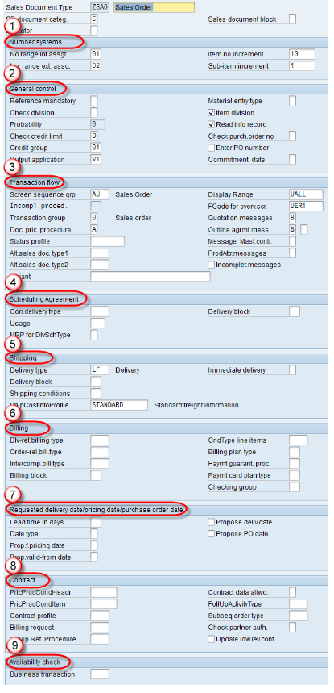

SD category - Maintain Type of document type - Inquiry, quotation, contract etc.
SD block - Select the parameter if you want to block from processing this document type.
Internal number assignment - Maintain this number range if you want system to generate the number for sales documents. Maintain the configuration number range in VN01.
External no. assignment - Maintain user has to enter - VN01
Item no increment - Maintain value like 10, 20
Sub-item increment - Maintain value if have BOM or other sub-items. Like 11, 12.
General control:
Reference mandatory-select choice - If you want any order to be created with reference to other document like Inquire, quotation etc.. If you maintain value here, system will not allow you to create Sales document without particular reference.
Probability: Probability of Converting inquiry or quotation in to sales order.
Credit check limit and credit group - if credit management active, setting is required. Credit group decides for which sales document it is active sales order, delivery, goods issue.
Check purchase order no and enter PO number - useful for order against multiple PO and Enter PO no - If it is marked, system won't allow you to save sales order without PO no.
Transaction Flow:
Screen Sequence Groups: Control the sequence of screens that appear when creating or processing sales documents, tailoring the user interface for specific transaction types.
Incompletion procedure: The system uses the incompletion procedure to determine which fields appear in the incompletion log while saving the sales order.
Transaction group-controls type of transaction you can process for documents types - VA01 cannot be used to create inquiry; it is useful for reporting later
Document pricing procedure: used to determine the pricing procedure in sales document.
Alternate sale document type 1 and 2 - can change selection of s.doc type in sales order.
Scheduling Agreement:
Correspondent delivery type - selects the delivery type.
Delivery block – Enter delivery block.
Shipping
Delivery type: Enter delivery type for sales document.
Delivery block: Enter delivery block for sales document.
Shipping condition: Sales document maintain in the document type which overwritten the value maintain in the customer master.
Billing :
Delivery related billing type: Enter delivery related billing type.
Order related billing type: Enter order related billing type.
Intercompany Billing type: Enter Intercompany related Billing type
Billing Block: Enter billing block for sales documents that must be checked before billing (for example, returns, credit and debit memo requests).
Billing Plan type: Enter billing plan whether its milestone or periodic billing.
Requested delivery date/Pricing date/Purchase order date:
Lead time in days: It helps to propose a delivery date in the sales document.
Date type: Enter date type. Day, week, month
Proposed pricing date based on requested delivery date: Control pricing date in the sales order.
Proposed delivery date - System automatically proposes as current date as proposed delivery date
PO Date - Proposal for Purchase order date.
Contract: This section control contract settings
Availability Check: This section control availability check settings.
Route Determination: ( Define : 0VTC/ Table TROLZ and TROIZ-Determination )
- Country & Departure Zone of the Shipping Point: under which the shipping point is located.
- Country & Transportation Zone of the Ship to party: This is stored in the General Data of Ship to Party. ( in CMR) (destination)
- Shipping Condition: It is the strategy for the delivery of goods from one location to other or customer. It is updated in the shipping tab of customer master data.ex. As soon as possible, imeediate shipping, standard
- Transportation Group: assigned to the material (Material Master: general plant date)
- Weight Group: It is used in re-determining the Route in delivery based on the weight of the item to be transferred. It can be used as an additional criterion for re-determining the route in delivery. e.g. you can set the route thru Air if the weight of the goods to be transferred is less than 10 Kg.

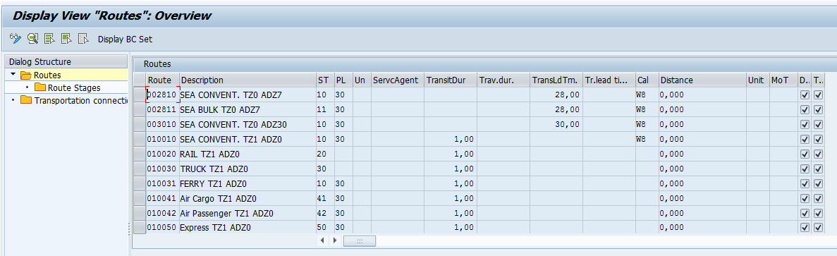
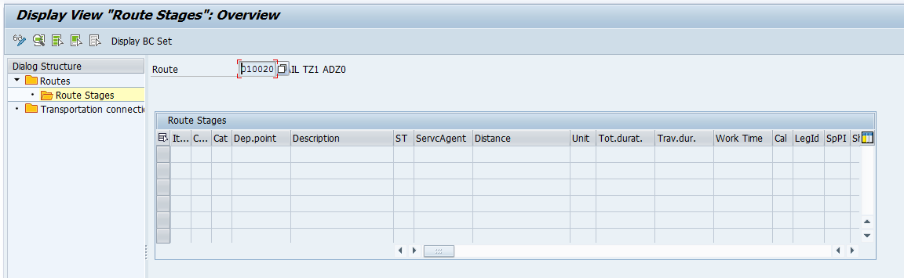

Output Determination
It is the process of determining output types into sales document. Output determination is based on condition technique.
1. Put the fields you will need into the field catalog.
2. Create the condition tables you will need.
3. Create the access sequence you will need.
4. Assign the condition tables to the access sequence.
5. Create the condition types.
6. Assign the access sequence to the condition types.
7. Create the determination procedure (if necessary) and assign the condition types to it.
8. Assign the determination procedure.
9. Lastly, create your condition records

- Define output type

- Cannot be changed: checkbox is blank The output may be changed during processing (as this).
- Multiple issuing checkbox : is blank, this indicates the output may not be sent more than once to the same partner.
- Partner independent output checkbox : is not active, the output is restricted to being received only by those partner functions as set in the Partner Functions folder
- Do not write processing log : is not activated is the do not write processing log, which if set will de-activate a very useful function of the output determination log in the process that is using the output—for example, in this instance, the sales order creation.
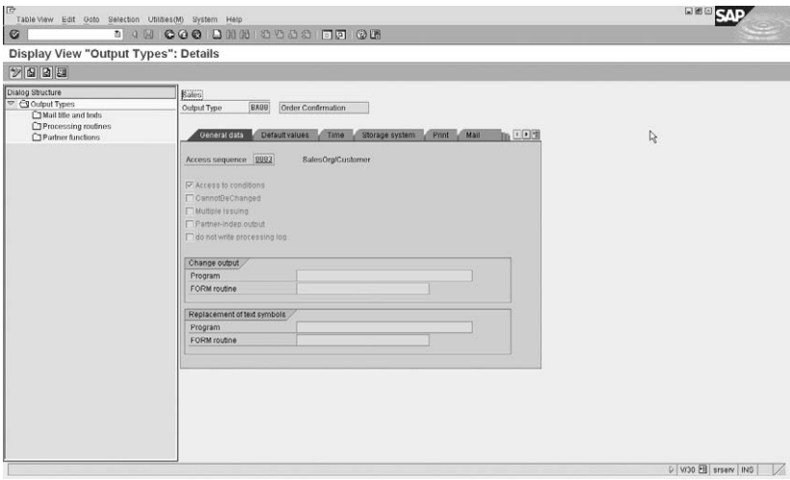
Output type and select the Default Values tab. These values entered per output type are automatically transferred as default values when creating a condition record by output condition.
The dispatch time has the following four options:
1. Send with periodically scheduled job
2. Send with job with additional time specification
3. Send with application own transaction
4. Send immediately
- Mail title and Text: texts (we maintain subject and body texts of a mail in mail title and Text
- Processing routines:
- Print program will help to get the data from Database tables to print in the output.
- FORM routine will help to do the calculations in output, Form Routine will help to include the logic in output.
- Form consists of layout of the output or the design of the output.
- Partner Function:
You may assign the allowed output types and processing medium to the partner functions. For example, you can assign the order confirmation as a printout to the sold to party, as well as the order confirmation as a fax to the sold to party.
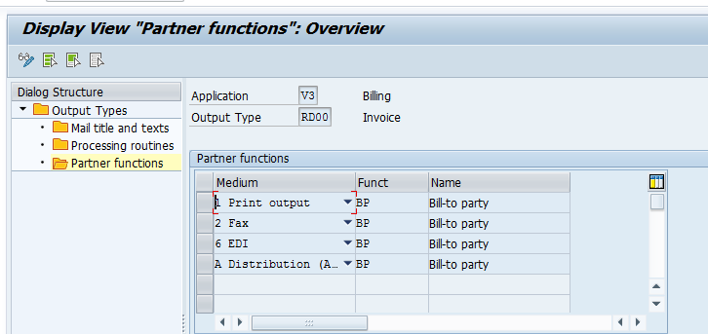

- Access sequence:
Access sequence assign to the condition table which consist of field catalog
Exclusive Indicator: Controls whether the system stops searching for a record after the first successful access for a condition type
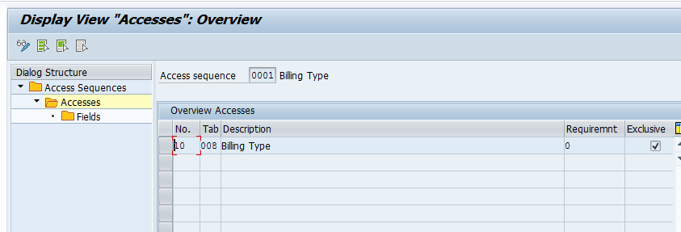
- Assign output type to partner function
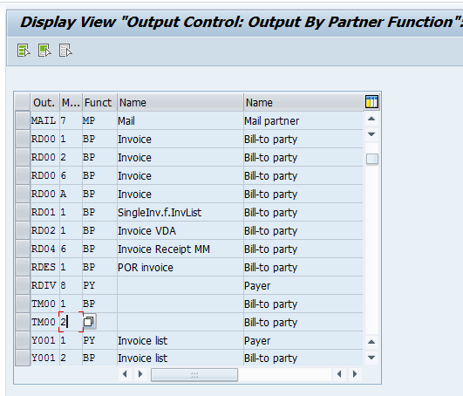
You may assign the allowed output types and processing medium to the partner functions. For example, you can assign the order confirmation as a printout to the sold to party, as well as the order confirmation as a fax to the sold to party.

- Maintain Output Determination Procedure
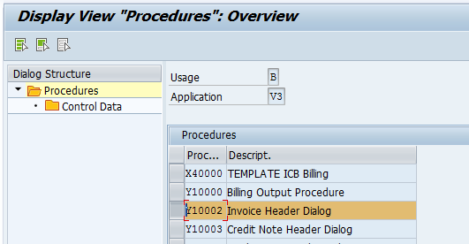

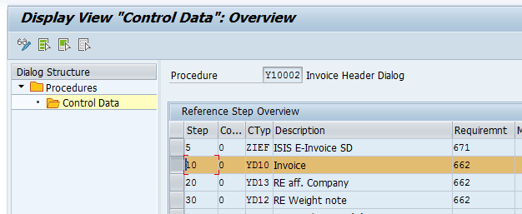

- In Billing Document
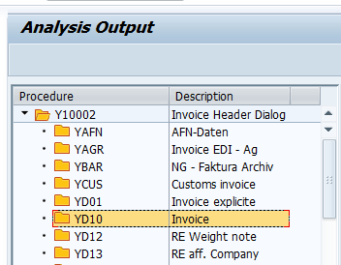

- Assign output determination procedure

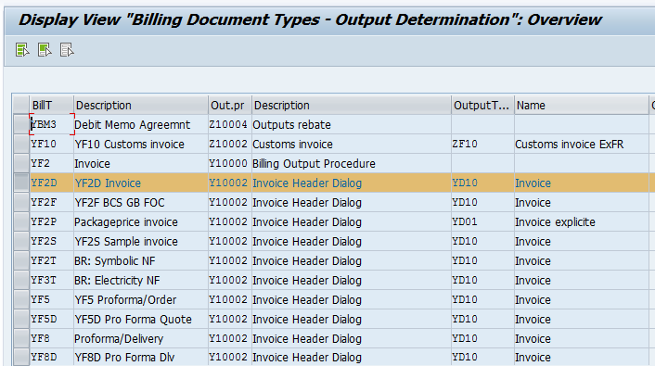
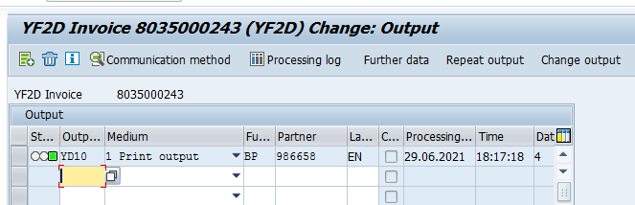

- Create condition record for billing

- [VV31] Create
- [VV32] Change
- [VV33] Display

Inside the sales document you may view the output by selecting Extras | Output | Header or Item | Edit. The buttons in the sales order output are :

• Communication Method that identifies the details as set in the communication area of the condition record that is the printer name etc.
• Processing Log records a log of the output already processed in the sales document(program details, any idoc is generated)
• Further Data displays if the output has been processed or not as well as the timing data—that is, is the output to be processed immediately or in batch.
• Repeat Output may be used to repeat already processed output.
• Change Output may be used to change the output.

PRICING
Pricing is based on condition technique. Condition technique is a process of determining condition records into sales document. Condition technique consists of condition records. Condition records will be stored in condition table. Condition table will be placed in access sequence from most specific to most general. Access sequence will be assigned to condition type. Condition type will be placed in pricing procedure.
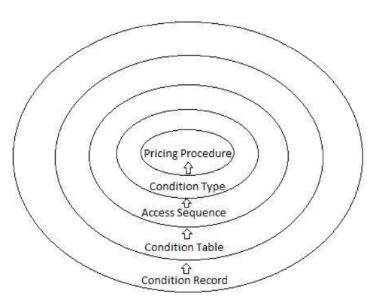

Condition records: - Condition record is the master data for pricing. We also call it as “pricing master”. The T-code to create condition record is [VK11].
Condition Table: - Condition table is the combination of field which will help to maintain the condition record.
Combination: - 1) Customer / Material
2) Pricelist / Material
3) Materia/
The T-code to create condition table is [V/03].
Access sequence: - It is a search strategy which will search for the valid condition record from the most specific to most general.
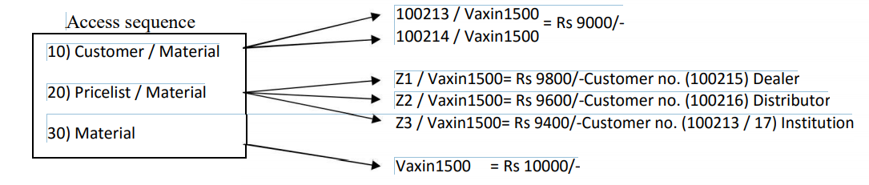
Exclusive: - Exclusive is one field in access sequence. If we check exclusive in access sequence then if system finds valid condition record at any of the combination then system will immediately come out of the search strategy and determine the price into sales document.
If we uncheck exclusive in access sequence even if system find valid condition record system will not come out of the search strategy. It will continue search in other combinations, if system find valid condition record in other combination then it will determine all the condition records into sales document.
The T-code to create access sequence is [V/07]
Condition type: - It controls the type of the price components i.e. whether it is a base price or discount or surcharge.
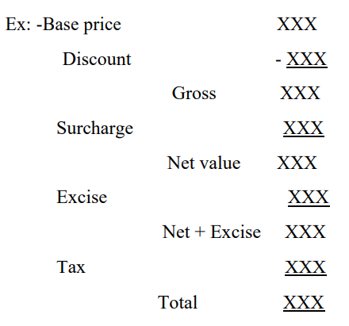

Pricingprocedure: - It is a procedure which consists of all the relevant condition types, which are placed in a sequence.
Pricing Proc. Determination: OVKK
1.Sales area
2.Document pricing procedure: sales doc type VOV8- Credit Memo(G), Free(F), Contract(V)
3.Customer Pricing procedure: Customer master- Standard, Standard USA, Animal Health
The T-code to create pricing procedure [V/08]
* The common T-code for total pricing is [VOK0] via condition technique

Configuration for Discount price
1 st step - Defining discount condition table: - [V/03]
2 nd step - Define discount access sequence: - [V/07]
3 rd step – Define discount condition types: - [V/06]
4 th step – Placed the discount condition type in pricing procedure: - [V/08]
5 th step - Assign pricing procedure to sales document type
6 th step – Maintain condition records for discount condition types: -The T-code is [VK11]
16 Fields of pricing procedure:
Step : Number that determines the sequence of the conditions within a procedure.
Counter : System uses the counter to count the steps and also it can be used to count mini steps of same condition types. So that number of steps can be reduced in the pricing procedure and hence enhancing the system performance.
During automatic pricing, the system takes into account the sequence specified by the counter.
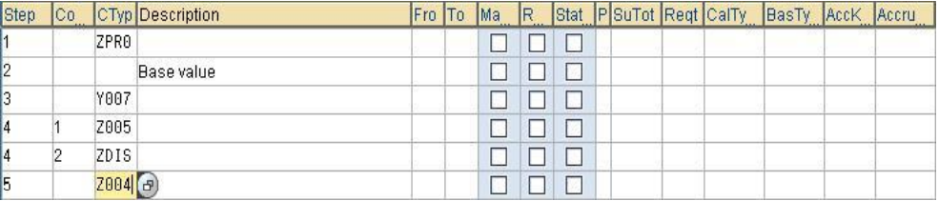
Condition Type : It represents pricing element in pricing procedure as a base price, discount, freight and tax
Ex.: PR00 - Price, K004 - Material Discount, K005 - Customer/Material Discount, K007 - Customer Discount, R100 – 100% discount
Discription : We use description to describe the condition types in sales document pricing, which will be useful for end users.
Ex. Price, Material Discount, Material Discount
From : This can be used as a base to the condition type for calculating further value.
From To : The range between the steps from and to can be used to specify the range between same condition types. So that depending upon the condition type, the system deducts or adds the total value of those condition types
Mannual : Any condition type if we check manual, then system will not determine the condition type automatically into sale document. User has to enter it manually in sales document.
Mandatory : Any condition type if we check required, then system will not allow to save the sales document if the condition type is missing.
PR00: Price ; MWST: Output Tax
- Statistical: This indicator if it is activated will not allow the value of the condition type to be taken into net value calculation. It is used only for information purposes only. This indicator causes a surcharge or discount to be set in the document statistically (that is, without altering the value).
This is commonly used for condition types.
- SKTO - Cash Discount
- VPRS - Cost (Moving average price/Standard Price).
Print: The value of this field specifies whether line item can be printed or not in the sales document and at what level it is to be printed.
Subtotal : It will be used to store the value of condition type in some temporary tables and fields for the purpose of further calculation.
Controls whether and in which fields condition amounts or subtotals (for example, a customer discount or the cost of a material) are stored.
These condition amounts or subtotals are used as a starting point for further calculations. You may, for example, want a subtotal of all the discounts included in the pricing of a sales order.
Requirement : Requirement is a condition which system will check every time while determining condition type into sales document. If the condition is fulfilling then only condition type will determine into sales document.
If the condition is not fulfilling then condition type will not determine into sale document.
The standard requirement is “55”. Requirement 55 checks that the Pricing field in item category should be maintain with “B” only for condition type R100 : 100% discount
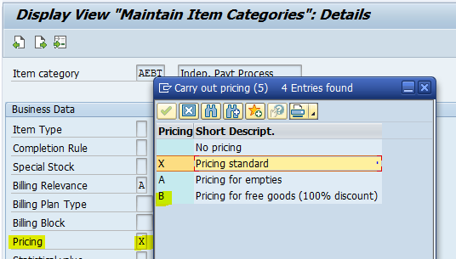
- Go to T.Code: VOFM. - Maintain Requirements & Formulas
- Click on the "Requirements" in the top menu and then click on "pricing".
- We have a list of requirements, we can ask ABAP consultant to create new requirement based on the client requests.
AltCty : Condition formula for alternative calculation type:
- It is again a Routine that is written by ABAP Consultant.
- It is an alternative formula for the condition type that can be used instead of standard formulas.
  - If we want discount to be apply on Net Price instead of base price then we will create such formula and written in the routine.
  - Click on the "Formulas" and then on the "Condition Values"`.
  - We have a list of routines, we can ask ABAP consultant to create new routines based on the client requests.
  - And we assign the application type.

AltCBV : Alternative formula for condition base value:
- It is again a Routine that is written by ABAP Consultant.
- It is used as a basis to calculate value of the condition type instead of using it from the "FROM" column.
- Ex.: Freight - KF00.
- Freight is calculated based on weight, volume etc. and not on the base price. In pricing there is no entry of weight from which the value can be referred like we do for discounts using base price. We have to get the value from the Material master.
- In this column we can mention the value as 12 - Gross Weight or 13 - Net Weight.
- During pricing, the system will consider the value that is mentioned in this column and determine the freight based on this value.
- Suppose we have Net weight: 100 kgs and Gross Weight: 150 kgs. And if we mention 13 in this column then the Freight condition KF00 will be calculated using the weight as 100 kgs.
AcyKy - Account Key/ Accrls – Accruals:
- The values of the Sales Revenues, Sales Deductions, Freight Revenues, Tax Revenues, and Rebate Accruals etc. are going to be posted in the respective G/L accounts in Fi Module.
- In order to do this we assign account keys/ accruals to the different condition types based on their classification. The classification shown below.
  - ERB: Rebate sales deduct.
  - ERF: Freight revenue
  - ERL: Revenue
  - ERS: Sales deductions
  - ERU: Rebate accruals
- For Ex.,
  - For all Price condition types like PR00 etc. we assign ERL - Revenue.
  - For all Discount condition types like K004, K005 etc. we assign ERS - Sales Deductions.
  - For all Freight condition types KF00 etc. we assign ERF - Freight Revenues.
  - For all Rebates condition types BO01 to BO05 we assign in Account key ERB - Rebates Sales deductions and for Accruals ERU - Rebate Accruals.
- This account keys and accruals are in turn assigned to respective G/L accounts. So the system posts respective values in respective G/L accounts in Fi-Co Module.
- This also one of the areas of SD - Fi Integration. SD consultants assign the account keys and Fi Consultants assign the respective G/L accounts in T.Code:VKOA

Define condition type: Tcode- V/06
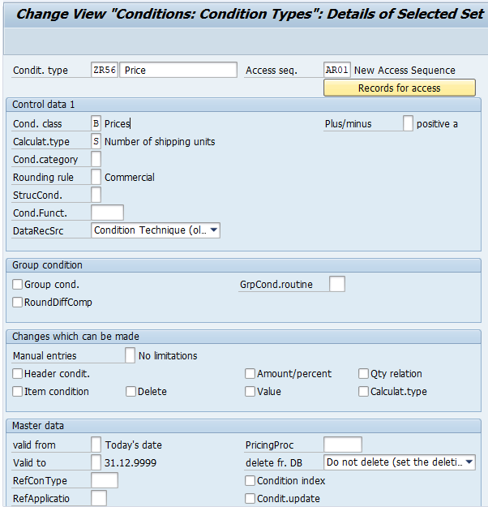
Condition Type: PR00=Price, MWST=Output Tax, VPRS=cost
Condition Class: It controls a condition type as to what purpose it can be used like prices, surcharges, discount, taxes etc. it defines purpose and behavior of condition type.
A-discount, B-Price, D-Tax
Condition Category: It specifies the classification of different condition types.
E-cash discount, H-Basic Price/internal/standard/moving, D-Tax
Calculation Type: How condition type will calculate the value as like percentage, fixed amount, quantity.
Rounding Rule: Amount will be rounded up/ down or commercial.ex.5.7=6
Scale basis: It specifies how the scale amount of condition type is calculated.
Value scale, quantity scale, net weight scale, Gross weight scale
Header/ Item Condition: Condition can be defined at these levels in the sales document.
Manual Entries: Enter condition type manually or get auto determined.
Group Condition:
Define price group- 01 in customer master and maintained a condition record like for price group 01- 10% so when you create the sales order if the customer is having the price group 01, automatically condition type will be trigger and will get the 10% discount.
What is the difference between group condition and header condition?
Group Condition: You can use this is feature of a condition type to apply price or discount for a material based on common property.
Header Condition: This is a manual condition which you apply to header (Condition screen) of a sales document. This amount is applicable to all items.
Usage of this feature is to apply price / discount for a specific group of materials.
1. You maintained a discount based condition record based on material group ( = 01 for example). You maintained scales also.
Qty Discount
1 - 10 Rs. 100.00
11 - 50 Rs. 105.00
51 - 150 Rs. 110.00 etc.
2. You are creating a sales order for a customer with five different items with different quantities as below
ITEM 1 - 25 No's
ITEM 2 - 3 No's
ITEM 3 - 12 No's
ITEM 4 - 27 No's
ITEM 5 - 62 No's
All the material is having the material group = 01.
3. While calculating the discount, because of this group condition, system add the quantities of items which have material group = 01. In the above example total quantity is = 109. System apply a discount of Rs. 110.00 to each item irrespective of the individual quantities.
4. If you have not activated the group condition feature, system determines the discount value based on individual item quantity which is as below.
Discount
ITEM 1 - 25 No's Rs. 105.00
ITEM 2 - 3 No's Rs. 100.00
ITEM 3 - 12 No's Rs. 105.00
ITEM 4 - 27 No's Rs. 105.00
ITEM 5 - 62 No's Rs. 115.00
Header condition types:Header condition types are manual condition types.These condition types can be entered manually in the sales order header level.this coditions will not have any Access Sequence.
EX :- HD00 - Freight.
You can see the difference between the Condition types HD00 - Freight( Header Level) and Condition type KF00 - Freight ( Item Level) because both are Condition Types used for the Freight.
If you see this in T.Code V/06 this will be not having any Access sequence in which the system will not look for the things wat ever the value you maintianed at header level it will directly look for that.

Intercompany Sales Process
1 Like 7,189 Views 0 Comments
Sales – Selling of goods from one company code to another company code.
Customer 1000 & Material 5000
Company Code 1234 | Company Code ABCD
Sales Org 1234 | Sales Org ABCD
Plant P123 | Plant PABC

- Customer 1000 punch an order to Sales org 1234 for the material 5000
- Sales org 1234 find the material 5000 is not available in plant P123
- Sales org 1234 decides to purchase the material 5000 from Plant PABC of Sales org ABCD
- Since Company Code 1234 and Company Code ABCD are different entity, the above movement refers as Intercompany process in SAP
Hence Receiving sales org will be 1234 and suppling Sales org will be ABCD. Mentioned below the configuration steps to implement the above business process.

Configuration Steps :
STEP 1: Intercompany Document type
Assign Intercompany document type to Sales document types in order to use the Intercompany sales process
Path: SPRO – IMG- Sales and Distribution –Billing-Intercompany Billing – Define Order types for Intercompany billing
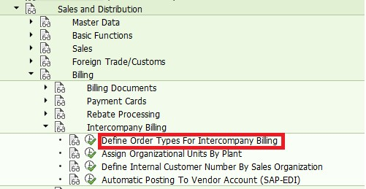

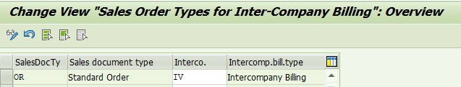

STEP 2: Plant Assignment
i) Assign Supplying plant to Suppling sales area (i.e.,) PABC plant will be assigned to ABCD sales area. This would be done in enterprise structure assignment and the same can be seen in the below path.
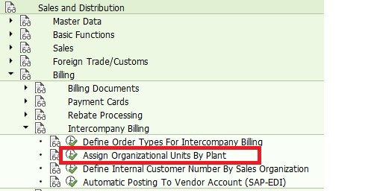
ii)Assign the Supplying plant to receiving Sales Org and Distribution Channel.(i.e.,) PABC plant will be assigned to 1234 12 12 sales area
STEP 3: Internal Customer Creation
i) Since Sales Org 1234 is requesting the Sales org ABCD to deliver the material, Sales Org 1234 will become a customer to Sales Org ABCD. Hence create Customer XYZ in sales org ABCD
XD01 – XYZ for ABCD Sales area
ii)Assign the created customer XYZ to sales org 1234
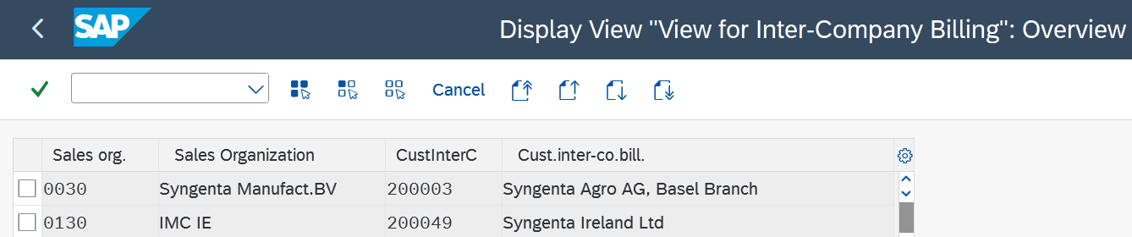
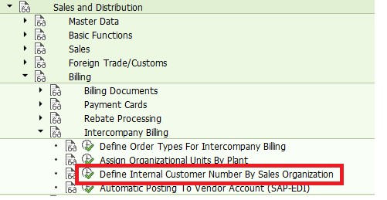
Conclusion :This completes the configuration steps for Intercompany Process.

Third-party process overview

In third-party process the delivery of the goods required by the customer is not done by sales organization where customer orders. Instead, the request of the goods is forwarded to an external vendor who sends the material directly to the customer.
Here is what happens in third-party process: (without shipping notification)
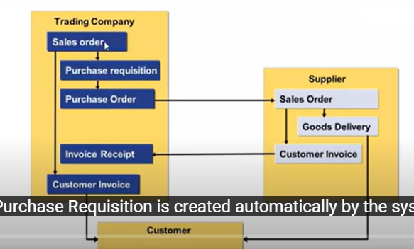
- Customer orders goods and we create the sales order to our customer in a sales organization
- Purchase requisition is created automatically when sales order is saved.
- Then it convert Purchase order and sent it to supplier (manually or automatically)
- If the supplier does the outbound delivery to the customer, the goods receipt can be posted in the system at company to cross check the quantities invoiced by the vendor and the quantities actually sent to customer (MIGO- invoice receipt vendor to company)
- From company Invoice to customer is created (MIRO- order based invoice)- Before creating invoice to customer.
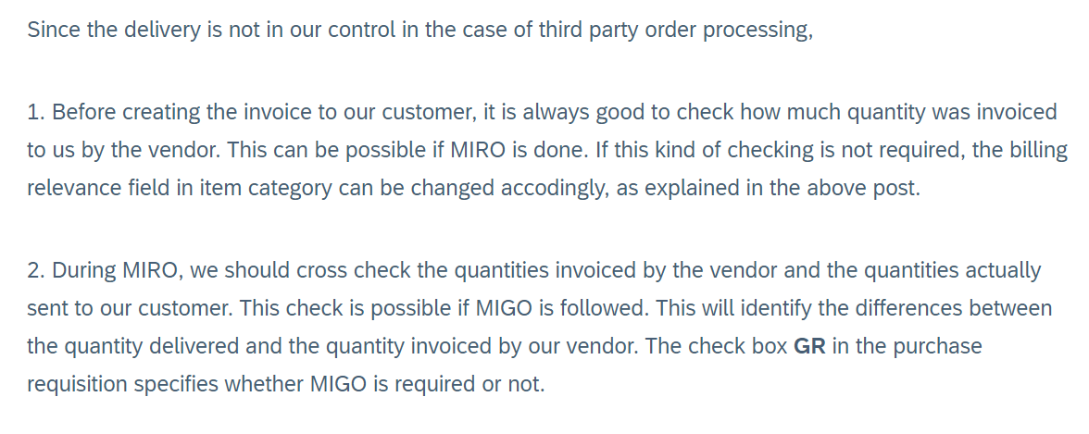

With Shipping notification: (with ASN)
When supplier delays to send a invoice and company want to bill anyway to customer in this case we ask supplier to send ASN in the moment that he delivery the good so in that moment we will create the inbound delivery in the system as advance shipping notification can be done manually or EDI. And when we post a goods receipt based on inbound delivery, we will be able to the bill to our customer, so we don’t need to wait to pause our logistic invoice verification.
Material master data
Item category group in sales view- BANS
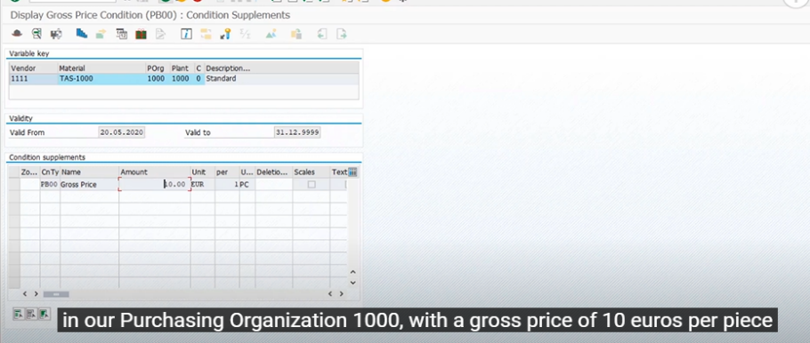
ME13- Info record for vendor
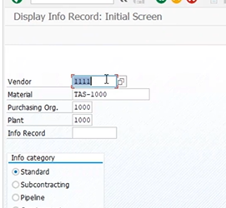
ME03- Source List- Fixing this vendor to material
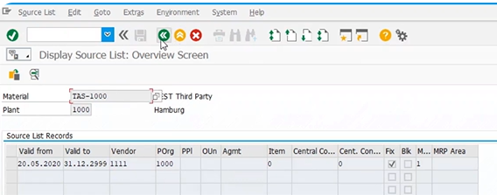
VK13- Maintain condition record for material - Sales org/division,
Sales order type used for third-party – OR (standard order
Item category for third-party – TAS
Schedule line category for third-party – CS
Let’s look deeper into the settings in the system done for automatic and standard third-party process:
ITEM CATEGORY TAS:
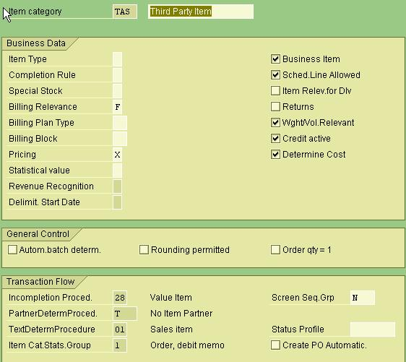
Billing Relevance F status according to invoice qty- means in third party sales, the order from the customer may be for 10 units but the vendor might have delivered your customer only 8 units and he has given the invoice to you only for 8 units in this case you can rise the bill to your customer only for 8 units that is invoice receipt qty.
Vendor send invoice receipt to organization and according to qty mentioned in invoice receipt, organization create customer invoice.
In ASN case Billing relevance is G: Order related billing of the delivery qty
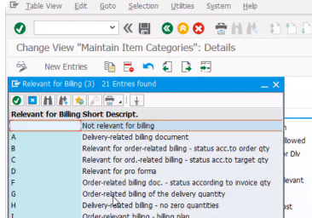
Billing plan type:
Milestone billing : particular work done client pays to the vendor
Periodic billing: client pays to vendor every month. Like month to month, week to week
Pricing: X is std. pricing
ITEM CATEGORY DETERMINATION
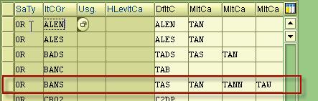
Item category group can be found in material master, Sales: Sales org.2 view.
SCHEDULE LINE CATEGORY CS
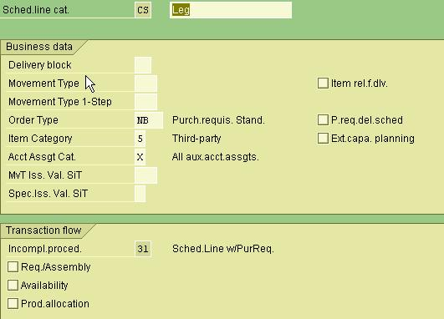
Order type = NB, Purchase requisition will create with order type NB
Item Category = 5, Acct.AssgntCat = X Good receipt flag is set up in X
SCHEDULE LINE CATEGORY DETERMINATION
Item Category + MRP Type
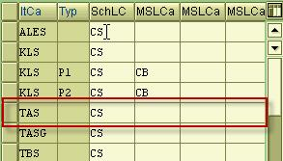
Copy control: VTFA- order to billing- For Item Cat TAS Billing Qty- F. Qty should match with the Invoice receipt send by the vendor
In case of ASN it is E- So that qty will be taken from the goods receipt instead of invoice receipt from vendor.
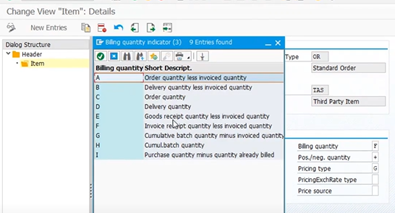
SALES ORDER-VA01
Once we save the sales order purchase requisition is automatically created.
Below we have the option to see the PR, by click on that we can see the fixed vendor and info record. If info record was not available then we can manually enter the vendor.
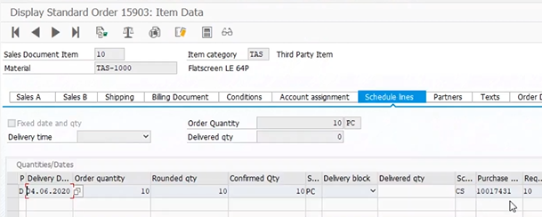
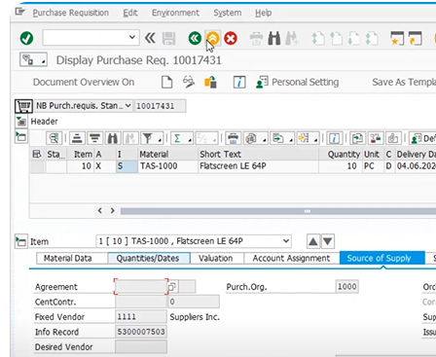

Convert PR into Purchase Order- ME21N
Enter the purchase requisition all details will auto pop up. In delivery section we can see the customer and delivery address. Once PO save it send it to Vendor.
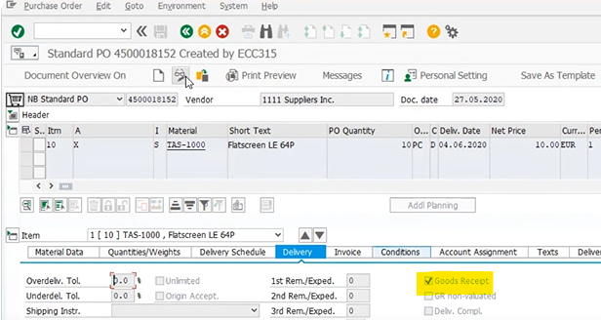

VL10B- Vendor does the Outbound delivery
MIGO- Goods Receipt- Statistical Purpose goods receipt
MIRO- Invoice verification
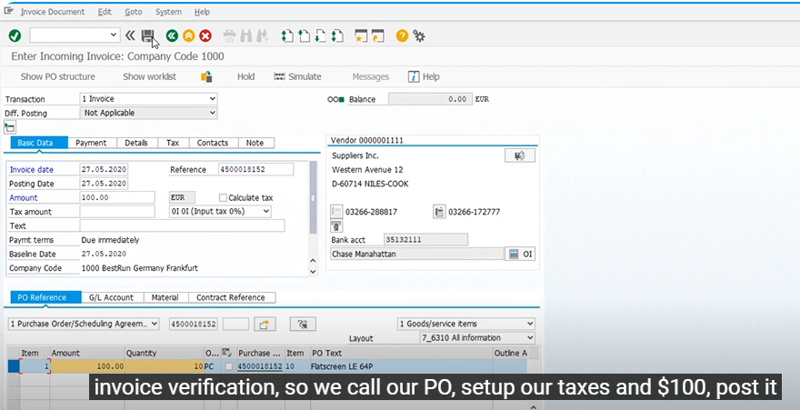
Create Customer Billing (from company)- VF01
Qty transferred based on the invoice verification.
With ASN flow:
Sale order- Purchase Requisition- PO- inbound delivery VL31N- PGR- Vf01
A purchase requisition is an internal document in which one department is asking another department for permission to buy goods or services. A purchase order is created after the requisition and is a document that is used to actually purchase those goods or services from an outside vendor.
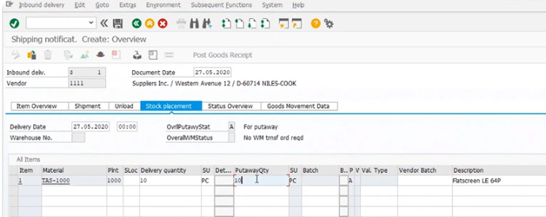
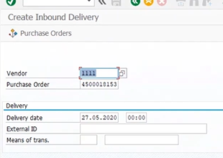
Consignment Process:
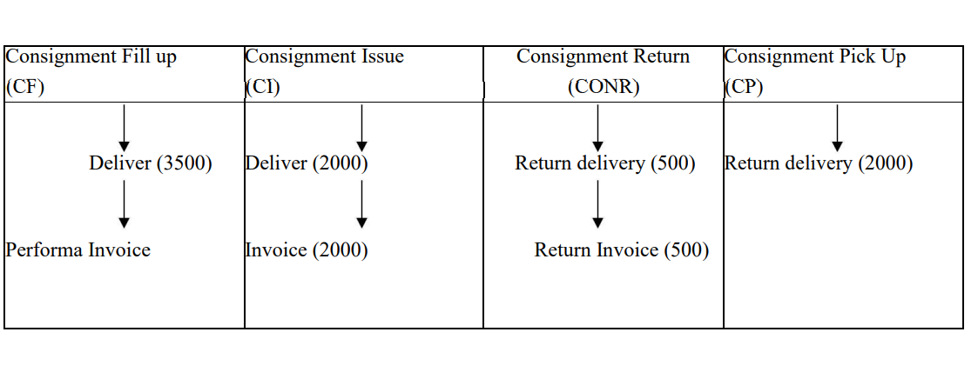
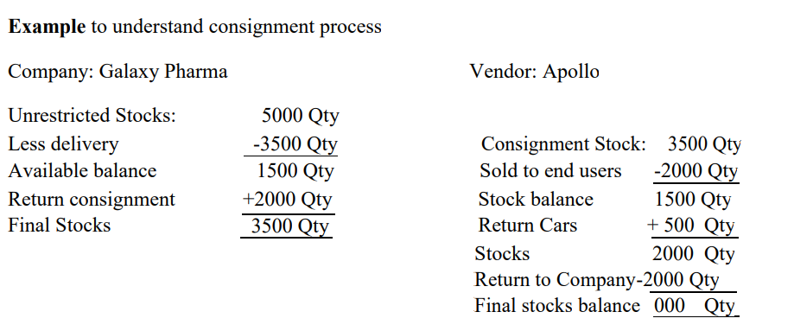
Consignment fill up:  Sales document type is KB- maintain delivery type in VOV8  Item category KBN- Billing, pricing not required.  Schedule line category E1-mov type, item rel. for delivery  Movement Type- 631  Consignment stock get added-MD04/ MMBE  Order  Delivery  Picking  Goods Issue  Billing | Consignment Issue:  Sales document: KE-Maintain delivery type and delivery rel. billing type in VOV8  Item category: KEN- special stock-W (cons. Stock), Biling rel.-A (del. Rel. billing), Pricing-X  Schedule line category: C0 or C1- mov type, item rel. for delivery  Movement Type- 633  Sending the goods to customer location.  Order  Delivery  Picking- 0VLP- delivery rel. item cat.  Goods Issue  Billing
Consignment Pick up:  Sales document: KA- maintain delivery type in VOV8  Item category: KAN- Billing, pricing not required.  Schedule line category: F0 or F1- mov type, item rel. for delivery  Movement Type- 632  Goods send back to company.  Order  Delivery  Picking  Goods Issue  Billing | Consignment Return:  Sales document type: KR- Maintain delivery type and delivery rel. billing type in VOV8  Item category: KRN- special stock-W (cons. Stock), Biling rel.-A (del. Rel. billing), Pricing-X, Return-Applicable  Schedule line category: D0- mov type-634, item rel. for del.  Due to damage goods are send back to consignment stock at customer location.  Order  Delivery  Picking  Goods Issue  Billing- credit memo

After consignment fill-up:
Item category KBN- pricing not required- as per this pricing set up system will not allow to enter any price but if any freight charges, Taxes applicable that we can enter.
Billing not required- Hence system will not allow to create the billing doc
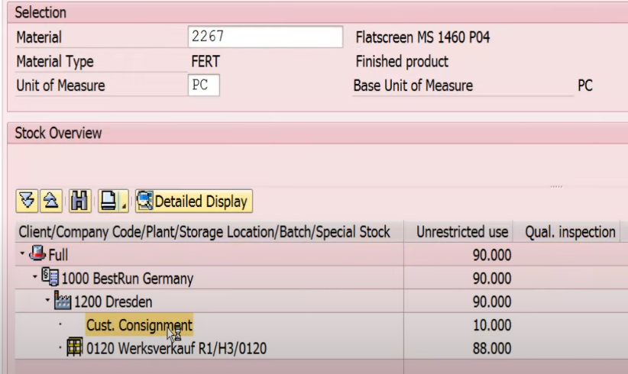
After Consignment Issue:
Cust. Consignment stock removed as qty of goods issued to customers.
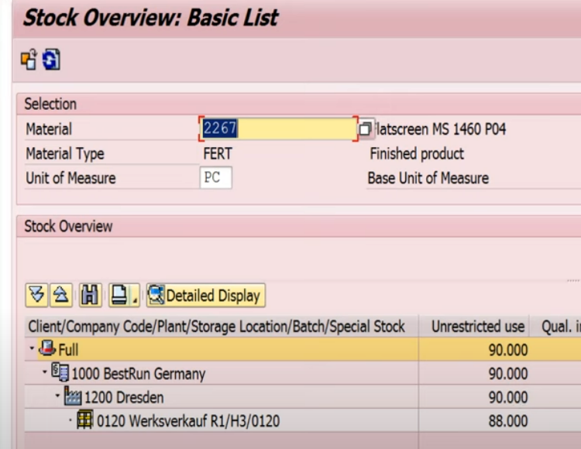

After Consignment Return:
Return qty-5 get added to cust. Consignment
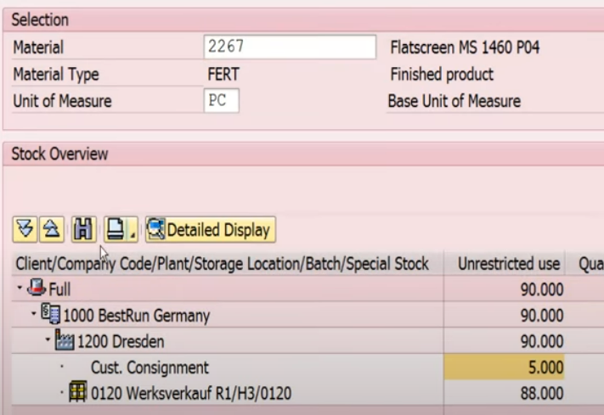

After consignment Pick-up:
Stock removed from Cust. Consignment and added to plant 0120
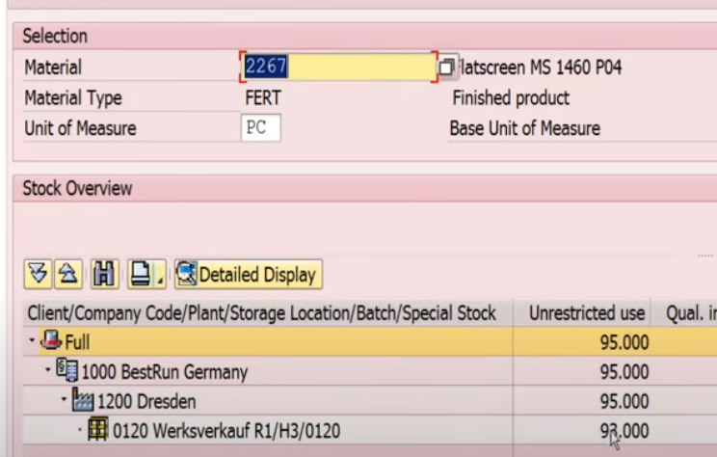

Text Determination
- Create text type
- Define access sequence
- Assign access sequence to text type
- Create text procedure
- Assign text type to text procedure
- Assign text procedure to

Customer master- customer account group
Sales document – header – sale document type
- Item – Item category
- Determine Material sales text at Item level in sales order

- Create text type

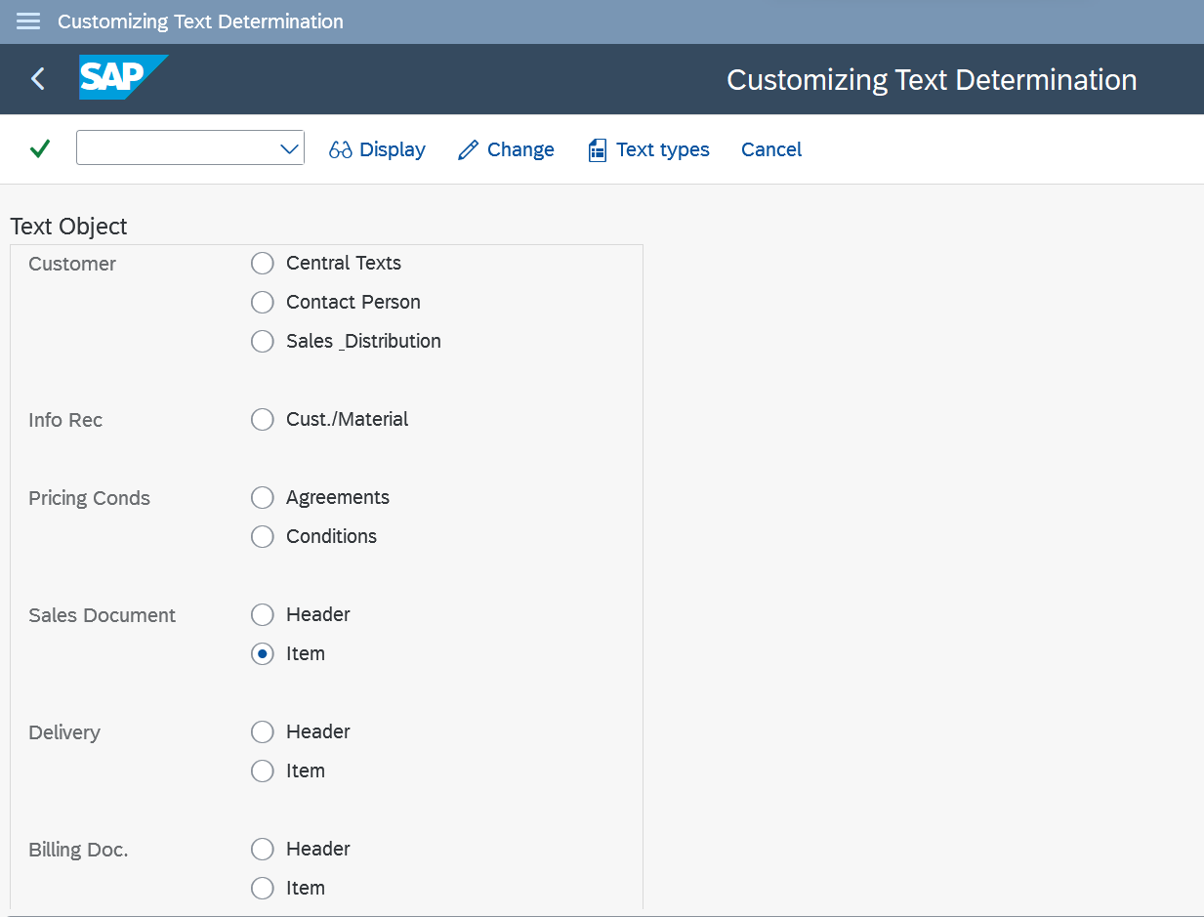

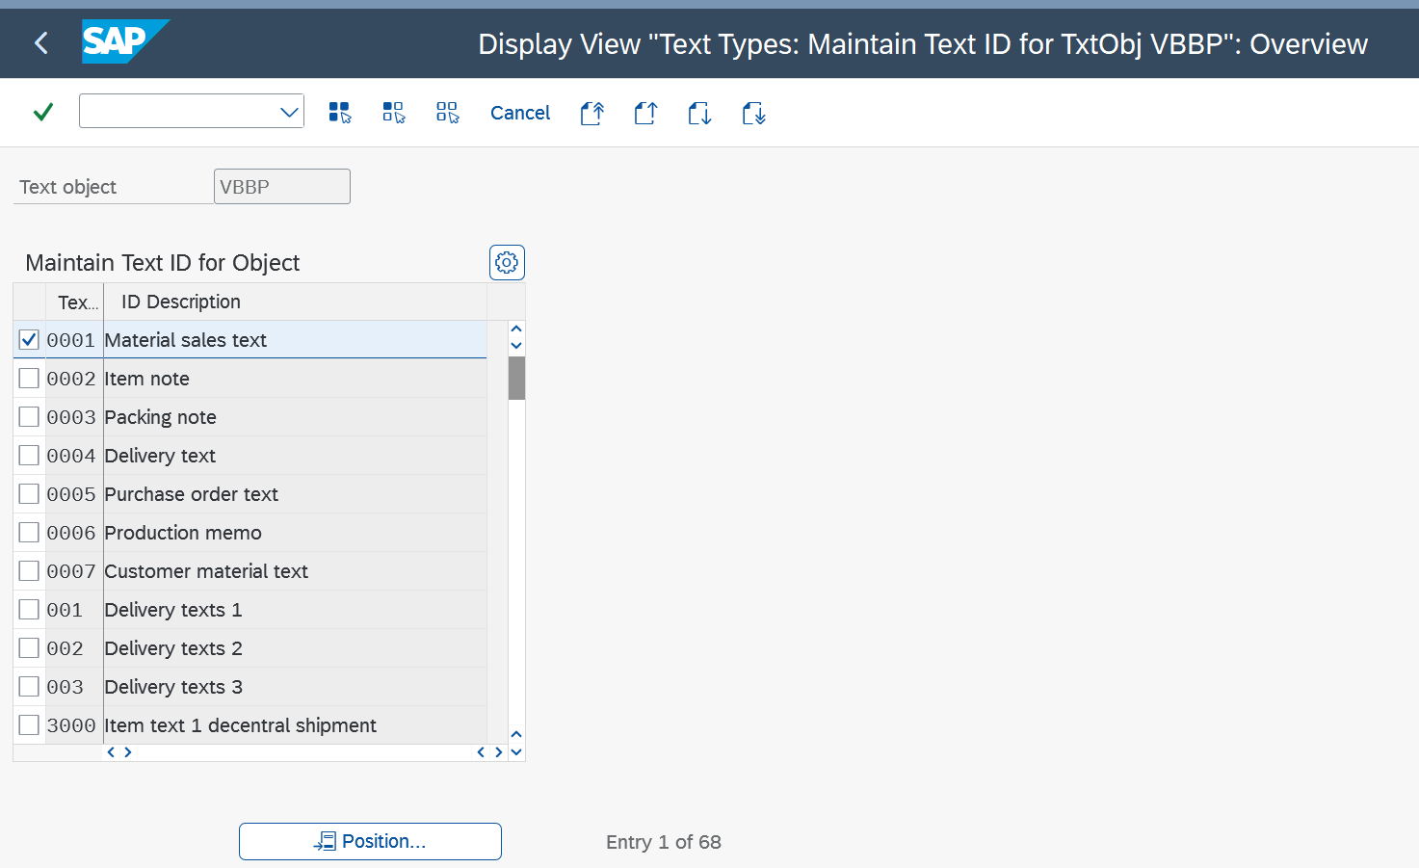
2.Click on change on initial screen and define the Text Procedure.2
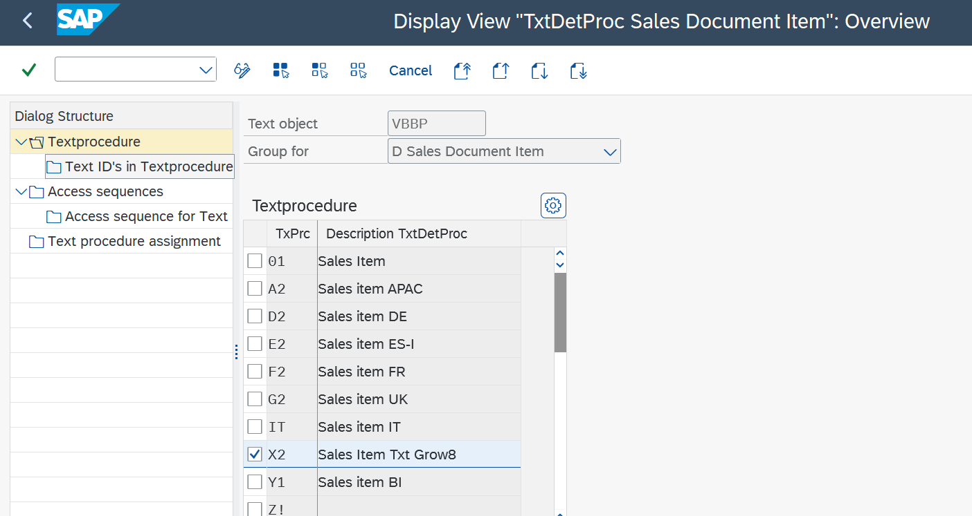
3.Define access sequence
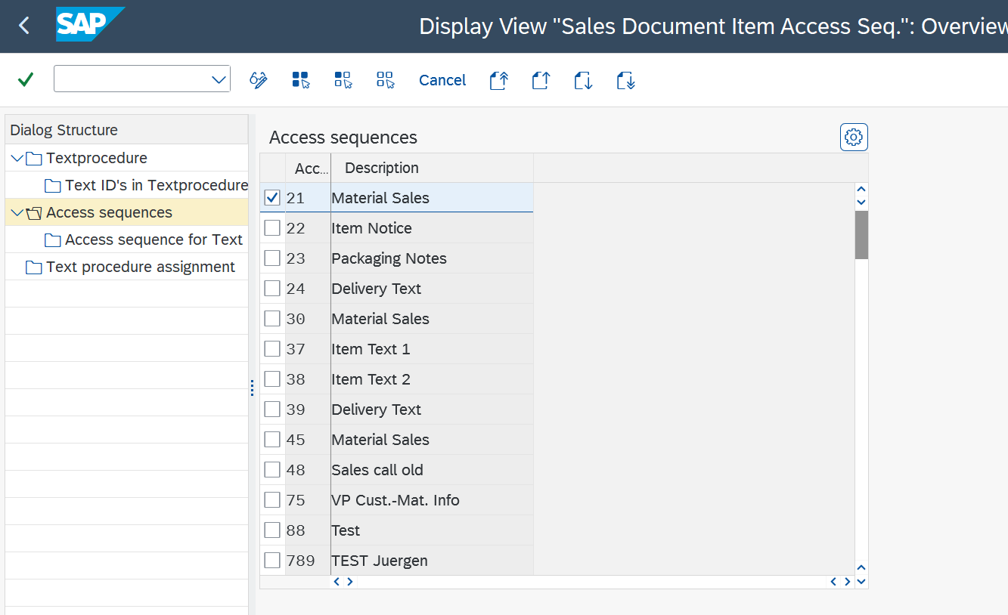

4.Assign text type (ID) to Text Procedure
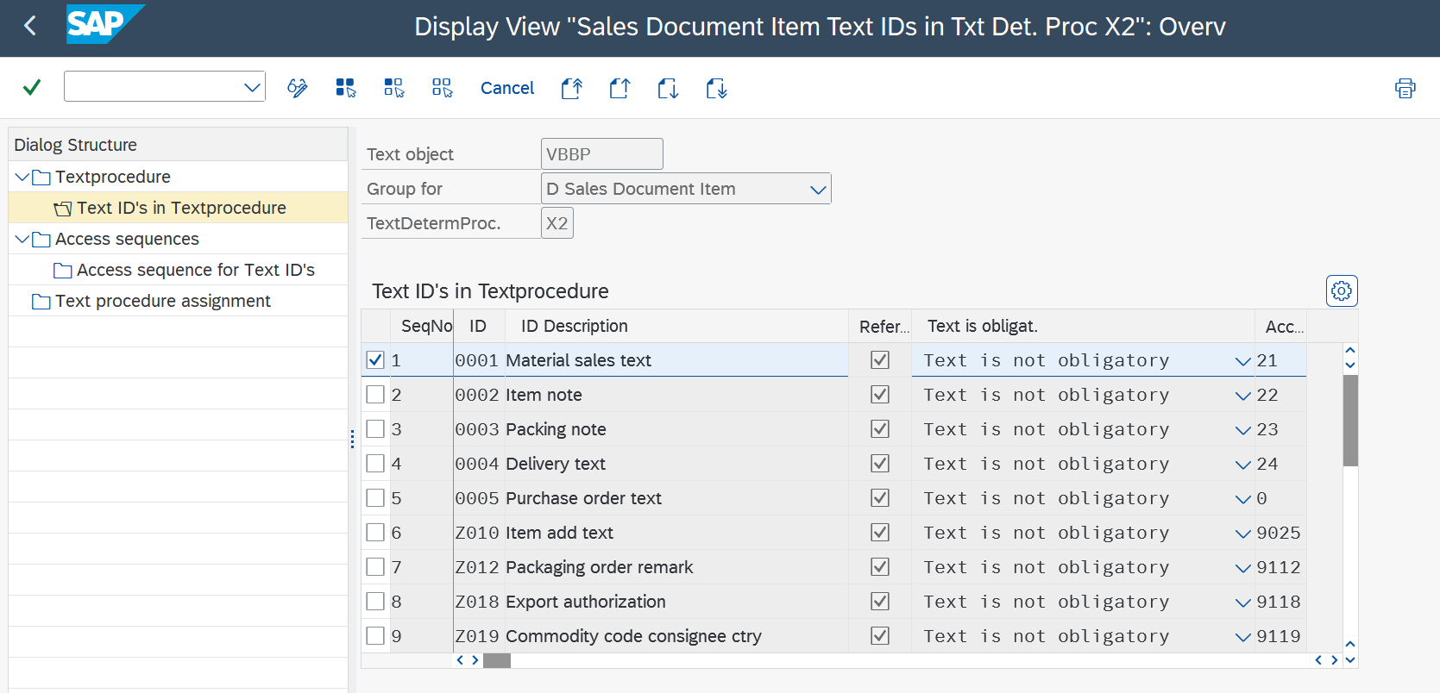
5.Assign access sequence to text type (ID)
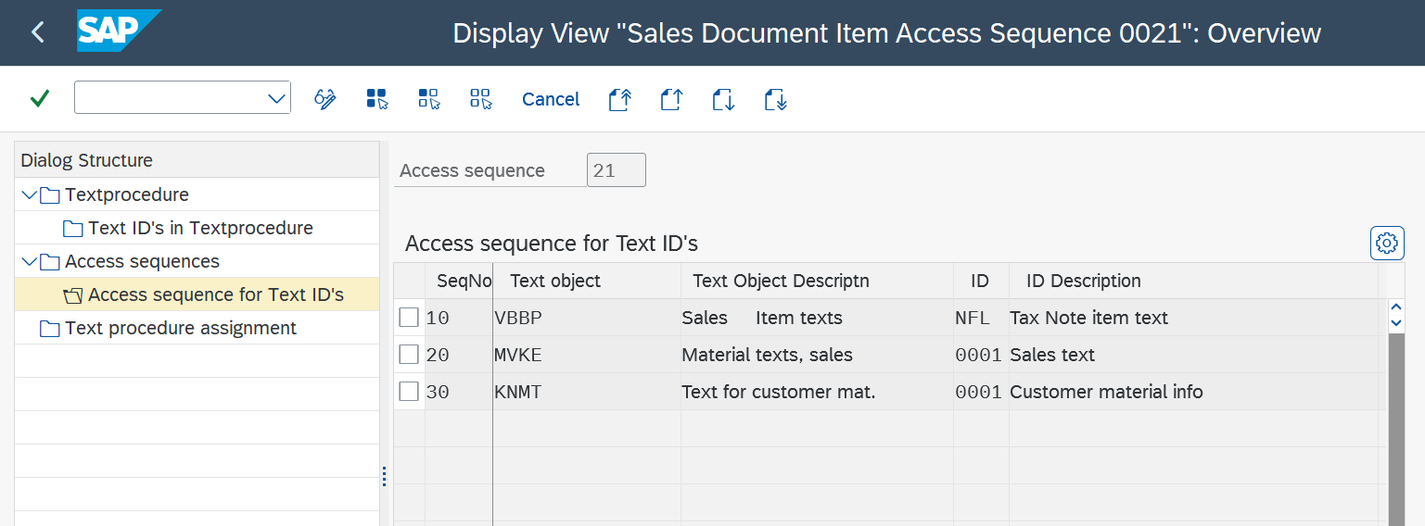
6.Assign Item category to Text procedure
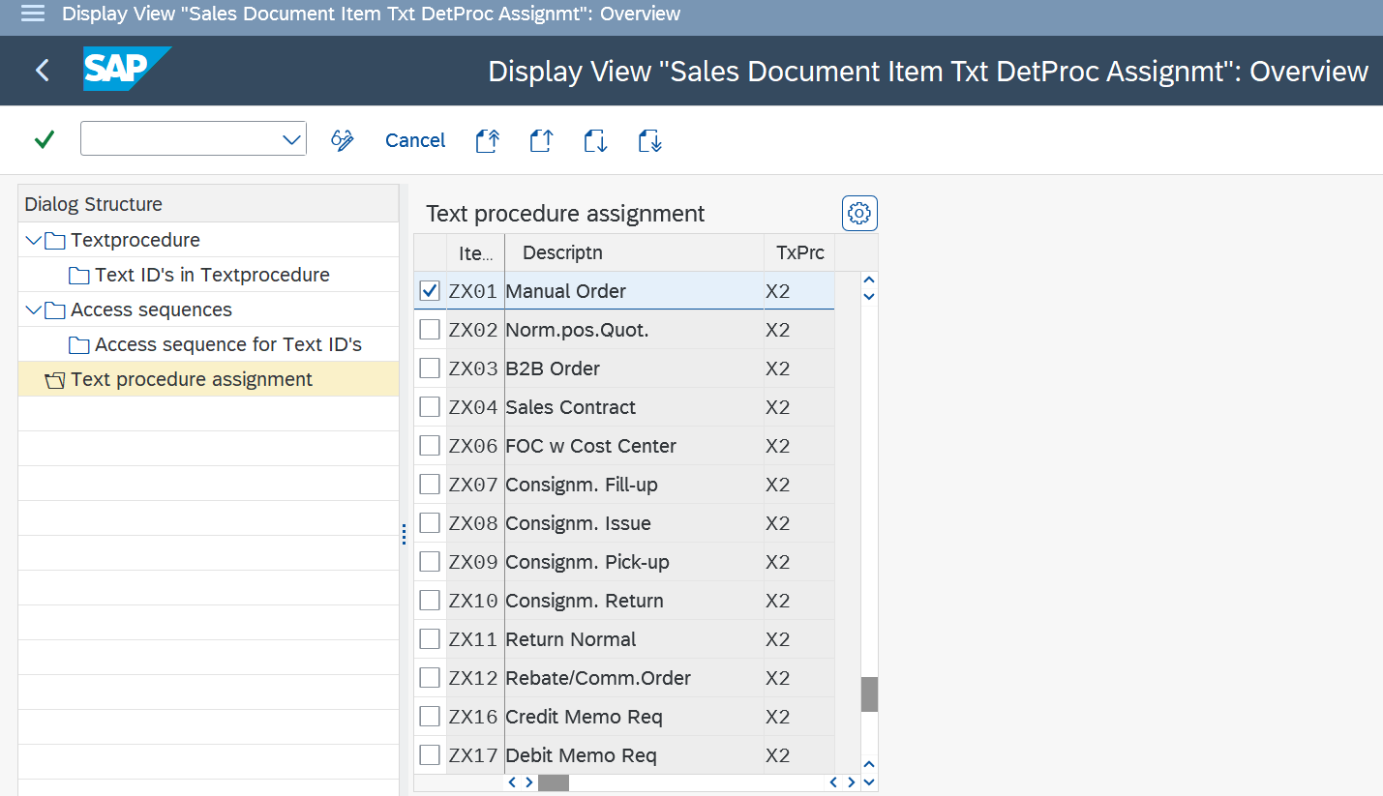
Partner Profile :
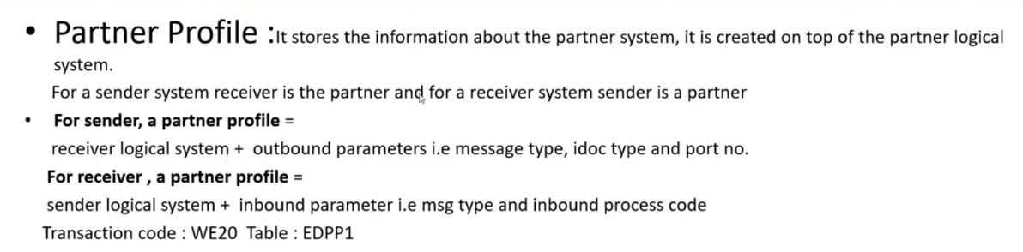

Partner Type LS – logical system
Used to transfer the sales document details from one partner to another partner.
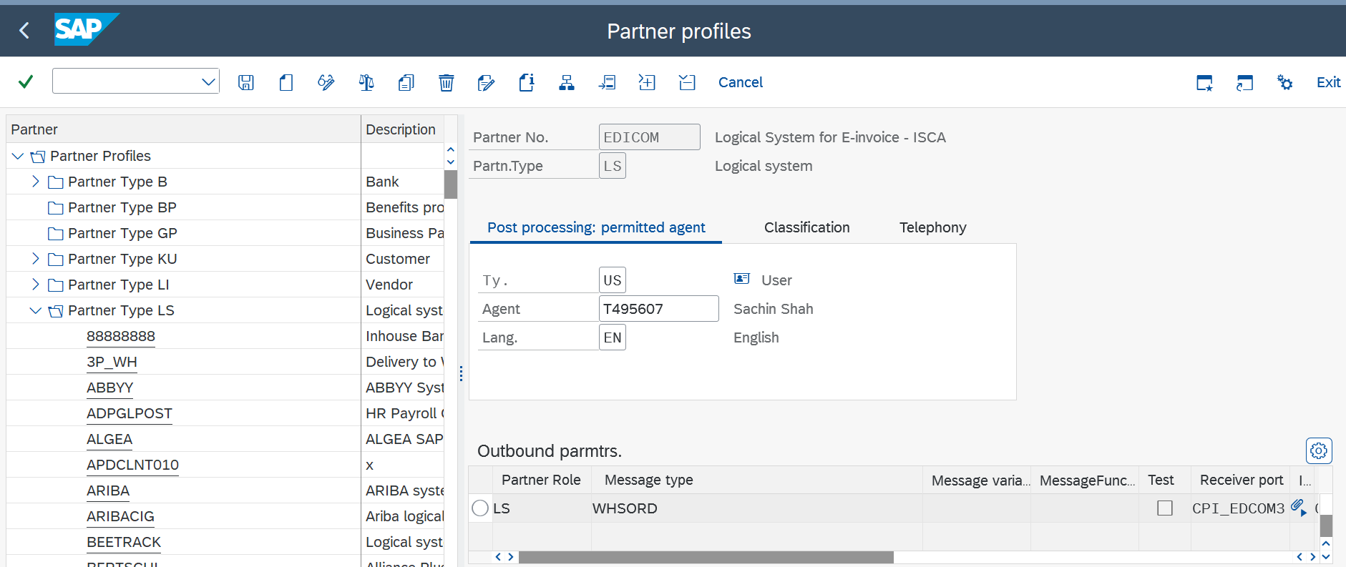
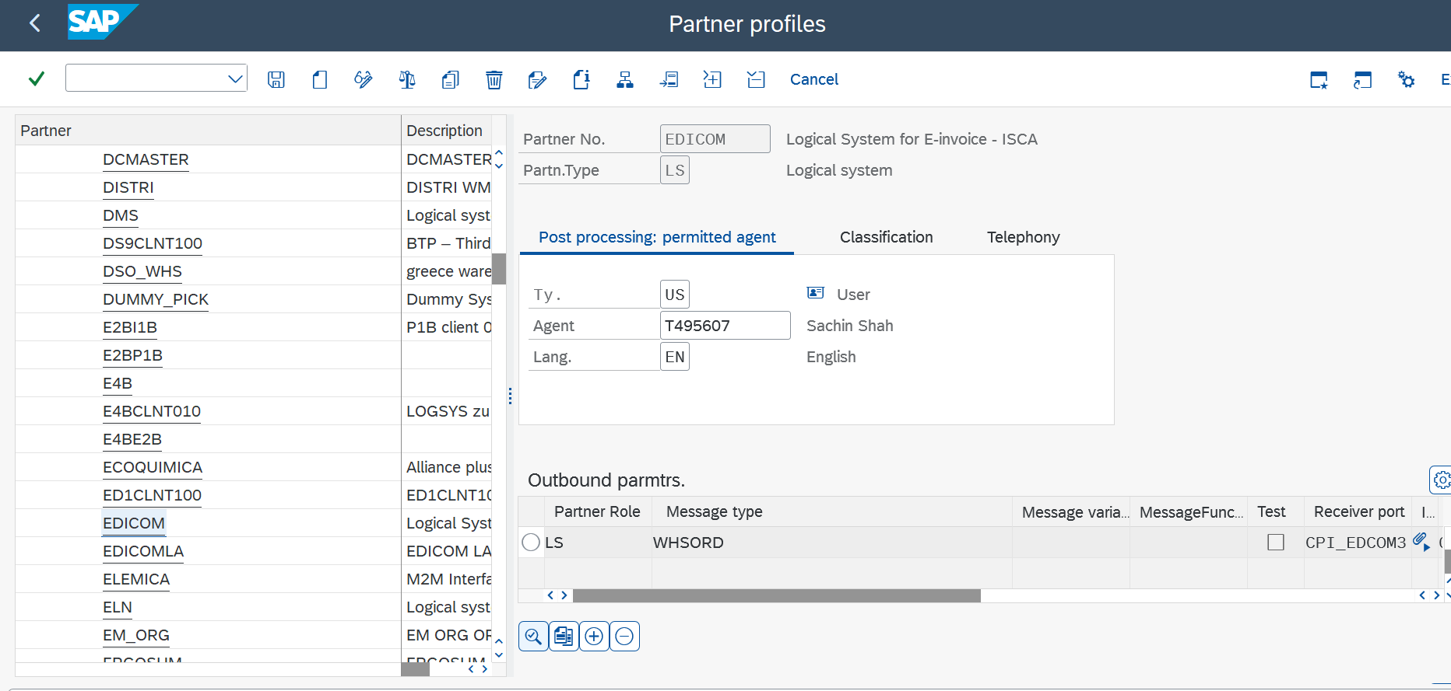
Double click on WHSORD
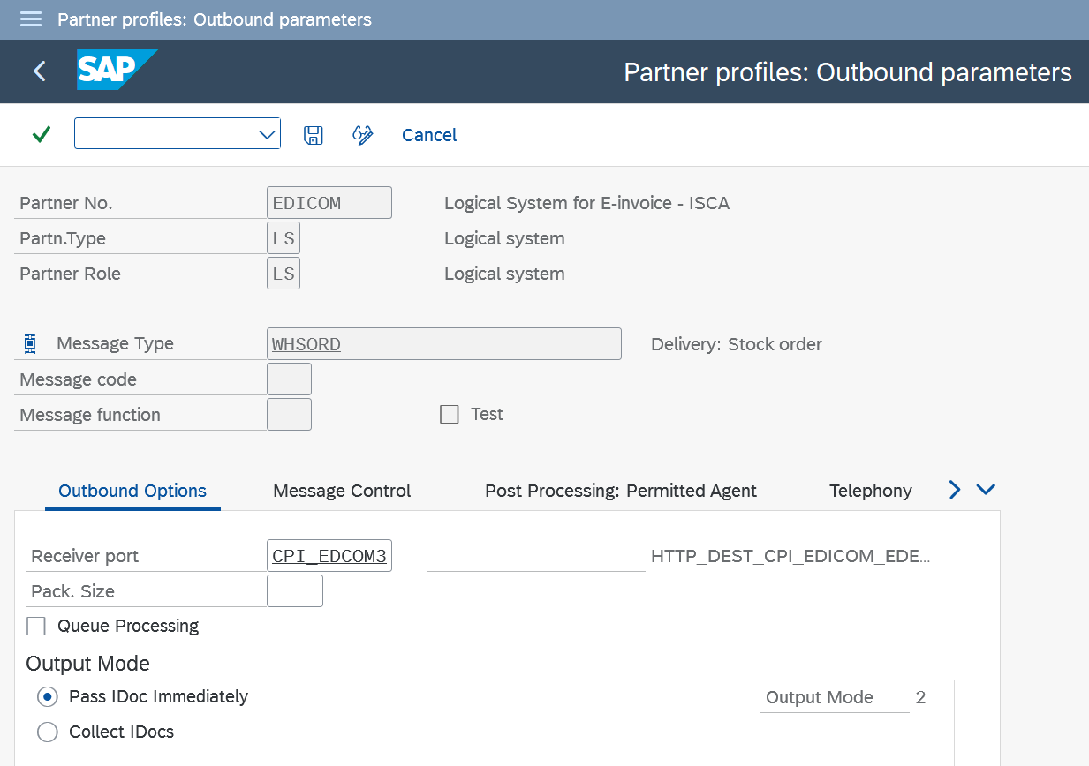
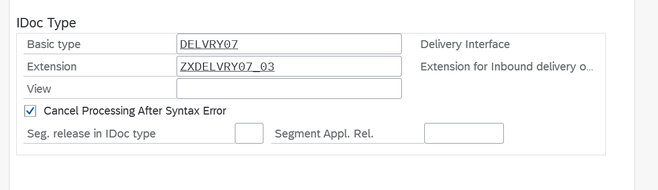
Click on message control:
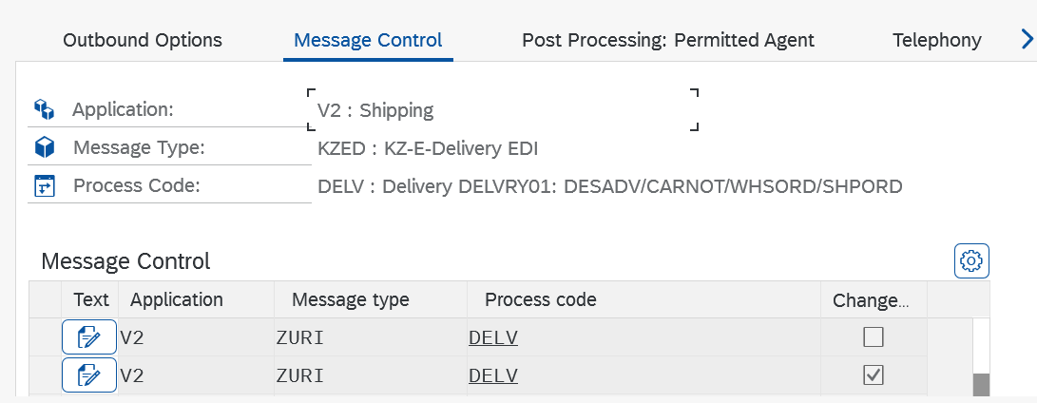
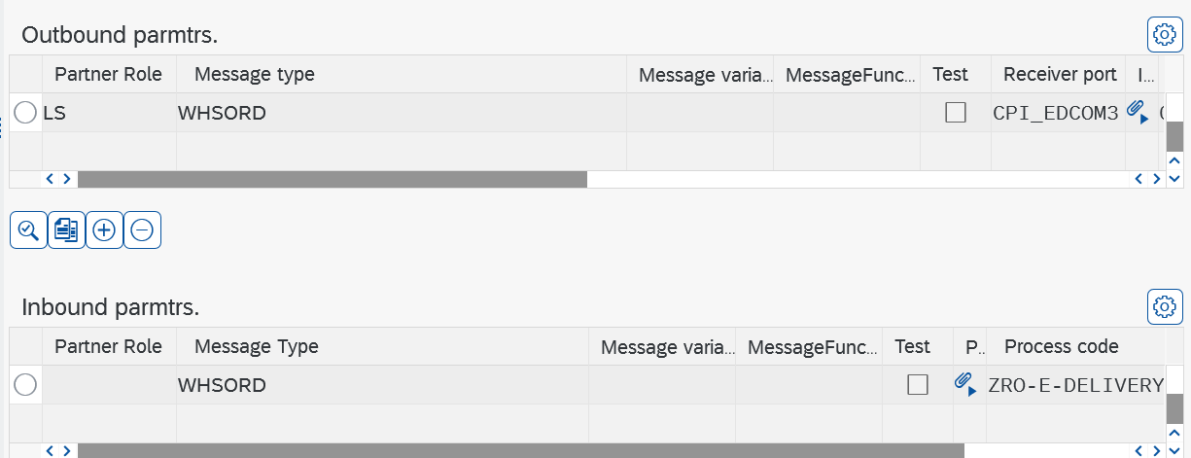
In inbound parameters click on WHSORD
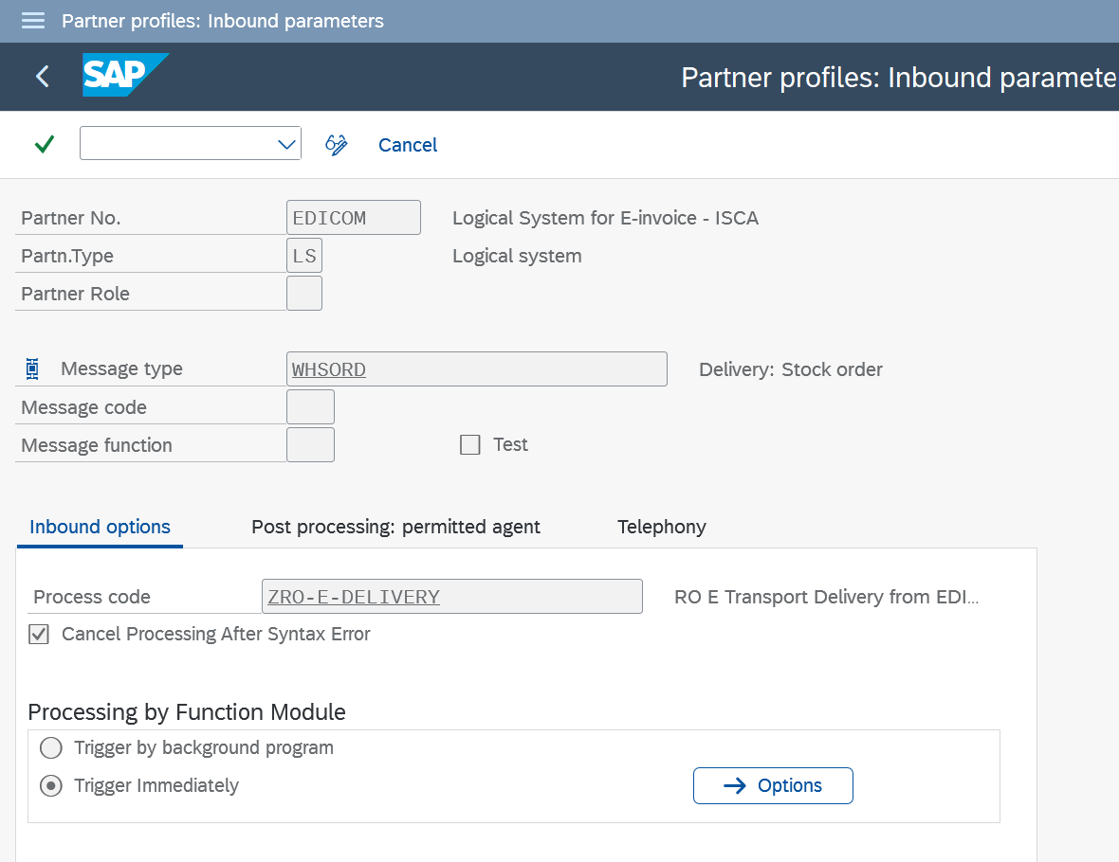
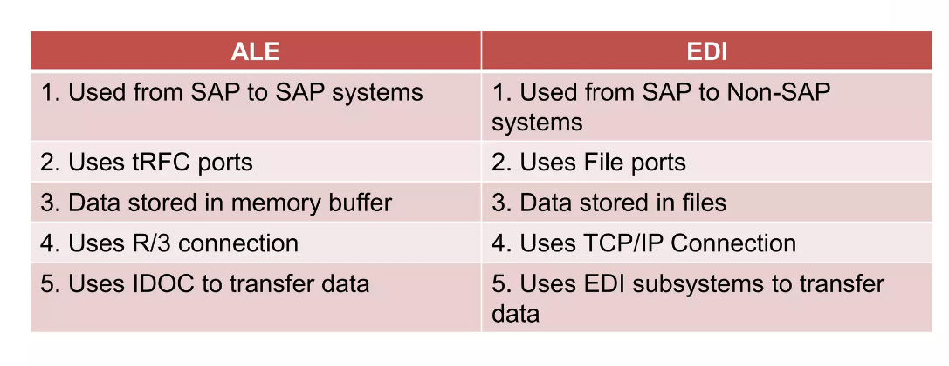
EDI is for exchanging transaction data (Purchase order, Delivery) between two different business partners. ALE normally used to distribute the master data (Ex: Material Master, Vendor Master) with in a company when you are maintain the distributed environment.The basic difference with ALE and EDI is ALE used for internal communications and EDI is meant for external communications.

Availability check parameters
Dates:-
Order Date – Date on which the sales order is entered. System proposes the current date by default.
Material Availability Date – The date on which the material must be available.
Transportation Planning Date – We must arrange transportation by this date, so that the delivery can be sent to the customer. The date from which the organization of goods transport must begin.
Loading Date – Picking and packing must be completed by this date so that the goods are ready for loading.
Goods Issue Date – Goods must physically leave the shipping point by this date. The date on which the goods must leave the company to arrive at the customer location in time.
Delivery Date – Customer should receive delivery of the goods by this date. The date on which goods are to arrive at the customer’s premises.
Times:-
Pick/Pack Time – Difference between the material availability date and loading date.
Transportation Lead Time – Number of days required for organizing a shipment for an item to be delivered.
Loading Time – Difference between loading date and goods issue date.
Transit Time – Number of days required for delivering an item from your company to the customer via a certain route.
The following data is required for determining this date:
- Route from the shipping point to the ship to party
- Shipping point from which the goods are issued
- Loading group from the material master record
- Weight group determined from the order using the order quantity
Material Master: relevant fields:
- MRP1 View: MRP type, MRP group.
- MRP3 View : Strategy Group.
- Sales org. 2: Item Category Group
Availability check :
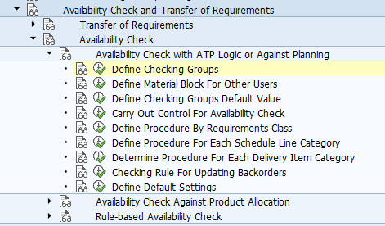

The checking group + checking rule determine how the availability check is to be performed.
Checking group/availability check: determines which type of requirement to be passed on to MRP whether it be individual or summarized .Determining the checking group- material type and plant maintained in the material master record. Specifies whether and how the system checks availability and generates requirements for materials planning.
1.defining Checking Groups –
Checking groups are introduced into the sales order based on the setting in the material master record.
SAP standard checking groups are 01 – summarized requirements and 02 – individual requirements or you can create your own by copying the standard ones.
i)Total sales and total deliveries columns: are there to configure a checking rule to sum up requirements to post to MRP either individually or by day or week.
II)Block quantity required can be set if you want several users to be able to process the material simultaneously in different transactions without blocking each other.
III)The no check indicator: is CHECKED when you DO NOT want the system to carry out ATP check.
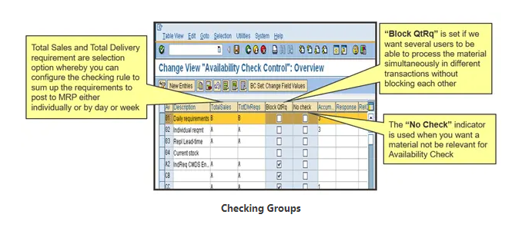

2.Defining material block for other users –It block material master records of a particular material during the availability check and restrict other users from accessing same master record and reserve the material. If the block is not set, two users can confirm the same material at the same time for two different orders, not knowing if the stock is available or not. a) Make changes in the material master record. b) Create purchase orders for the material. C) Create orders for the material.
3. Defining default values for checking groups - if the checking group is blank in material master record, a default value can be set here, depending on material type (MMR) and plant(sales order).
If an entry exists, this default value is over written by MMR.
4. Controlling Availability Check – It tells hon hand, inward/outward stock to be consider when performing the availability check. And also whether or not to consider the replenishment lead time.
On hand stock- safety stock, stock in transfer, block stock, restricted stock.
Inward/outward stock- PO stock, PR stock, reserved stock.
5.Define procedure for requirement class : controls whether availability check and TOR is carried out for a transaction. Whether the requirements are relevant for MRP
Requirement Type : which identify the different requirements Ie. Sales order requirement, delivery requirement, individual customer requirement. Together with the item category and the MRP type of the material allocate to individual transactions in sales and distribution is carried out by means of the requirements type.
Define Procedure For Each Schedule Linea Category: controls whether availability check and TOR is carried out for Schedule Line Category of the sales document. (sales Order)
Determine Procedure For Each Delivery Item Category: controls whether availability check and TOR is carried out for delivery item Category of the sales document. (in Delivery document)
Example- When Two orders get created, stock is available at order level. And suppose after a day available qty is 10 which get allocated to one order. At this time for second order ATP check is done at delivery.
Checking Rule For Updating Backorders: It is the checking rule which is to be used for orders in which the delivery date which is decided on the availability of material is already passed compared today, hence these orders are to be rescheduled by releasing the old availability date and to fix the new dates for delivery.
Plant and checking rule assignment (BO)
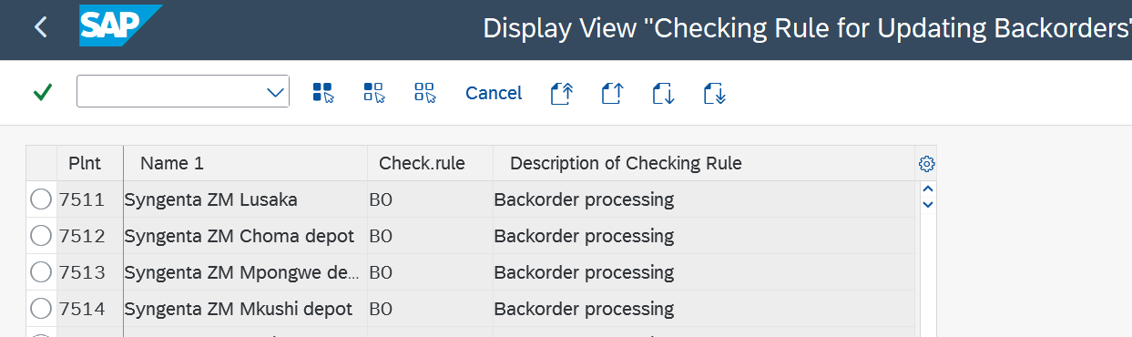
No storage location inspection: It is possible to indicate to the system that you would like the availability check NOT TO CHECK the stock at the storage location level. This indicator is used to set the scope of the availability check.
It is used to switch off the check at storage location level. You create a reservation for a particular storage location. However, the scope of the availability check is set in such a way as to exclude the storage location. In this case, the system carries out the check at plant level only and does not take the storage location into account that is specified in the reservation.
Check without RLT: Should you not want the system to automatically check RLT, you may indicate so here. RLT is the time taken for a material to become available. It is only used when doing an ATP check and is taken from MMR.
Define Default Settings
For each sales area which is a combination of sales organization, distribution channel and division, you can set an indicator for fixing the date and quantity as well as a rule for transferring the results of the availability check.
- Fixed date and quantity
In this field, you specify for a sales area whether the delivery dates and delivery quantities confirmed after an availability check should be set.
- Rule for transferring the availability results
In this field, you can specify the system response to shortage for a sales area. The following responses are possible:
Scope of Check - This shows the Stocks & Movements that system considers for availability.
Checking Group + Checking Rule > (determines) > Scope of Check
Actions
1. Specify for each sales area whether you want to fix the date and the quantity.
2. Specify for each sales area whether a system response should be issued if the availability check shows a shortage, and if so which.
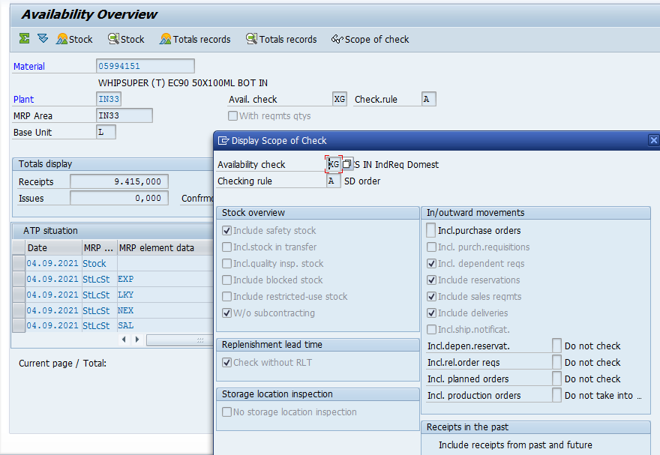
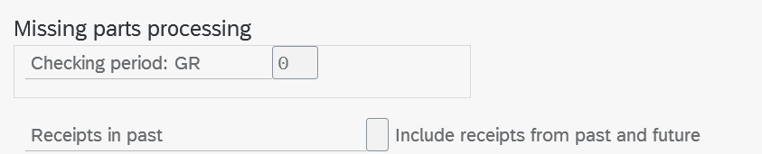
MRP: Helps manufacturer plan, schedule and manage their inventory during the manufacturing process.
MRP Type: Used to regulate material requirement planning. It determines how and when the material is to be planned or to be available for the requirement. PD, ND
MRP Type PD: relevant for MRP, ND: Not relevant for MRP
For PD case normal process followed of MRP or ND case manually production order created. As per requirement it will get process like MTO
Set in material master MRP 1 View
MRP Group: MRP group is responsible for separate planning for the material. you can use to assign common control parameters to a group of materials for planning and organizational purposes. You can group materials using MRP Groups. Each of the MRP Group can have its own MRP Parameter set. Set in material master MRP 1 View
MRP group is used for planning of material, where different dept is not able to run MRP individually. so group is created and assigned that grope for all material which undergoes for MRP.
MRP Controller: Responsible for material planning and execution.
Set in material master MRP 1 View
Strategy group: groups all the planning strategies that can be used for a particular material. The planning strategy represents the procedure used for planning a material and is (technically speaking) controlled by the MRP types.
Make to stock: - Irrespective of the customer order we manufacture the goods and keep stock of it. When orders come then we deliver the goods from the stock. If it is make to stock then we maintain strategy group as “Blank” or “10”.
Make to Order: - When we receive the order from customer then only we start manufacturing the product because the specifications of the products is not standard. Every customer will place order with their own specifications. For make to order maintain strategy group “20”. This field will help to determine requirement type into sales document. The criteria for determining requirement type into sales document. 1. Strategy group 2. MRP group 3. MRP type+ Item Category

How availability check is perform:

Based on material type and material strategy/requirement type MRP done – Scheduling (forward/backward) – Next delivery date calculate with confirm quantity – order confirm

TVS Bike- Company using two types of Tyre- TVS Tyre, and MRF Tyre

Setting In material master, Procurement type- In house and external procurement

Inhouse- How much time it will take to bring the stock

External- How much time vendor required to send the goods.

RLT Time- Replenishment time- Time required to manufacture the goods.

Backward scheduling- Suppose customer want bike delivery at the end of the month. System will consider the date and time parameters defined above and calculate the time required to manufacture and make the bike available. Suppose including all consents it takes 2 week so system will calculate the date before two weeks of end of the month and from that date manufacturing will start.

Forward scheduling- On the required date of delivery if the bike is not available then system will calculate the next date on which bike will be available. Basically it confirms the date of delivery.
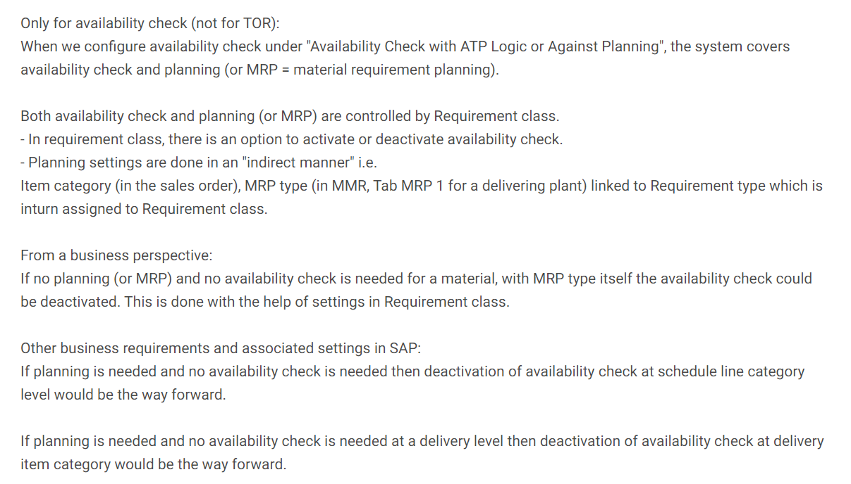
Handling Unit:
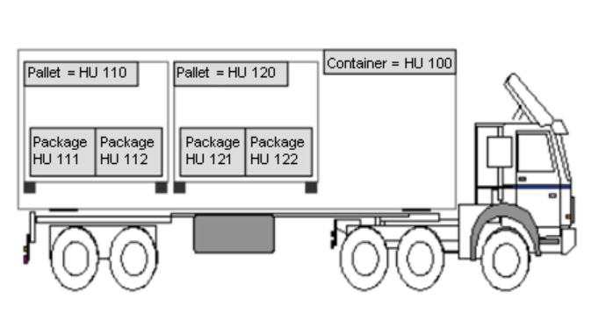

Set in material master MRP 3 View
Plant data/storage 1 :Shelf life data (material expiry we can check).
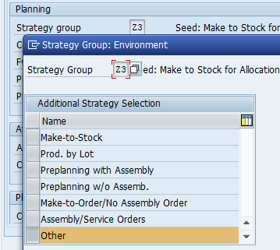

Which methodology we have used in the project: Agile
you cannot say that one is better. It depends on the project and team’s goals, resources, constraints, and deadlines.
Waterfall is best suited for projects with a clear set of requirements that don’t change much over time and where risk and uncertainty are low.
Agile is best suited for projects that require frequent changes and updates.
Agile Project Management | Waterfall Project Management
Client input is required throughout the product development. | Client input is required only after completing each phase.
Changes can be made at any stage. | Changes cannot be made after the completion of a phase.
Coordination among project teams is required to ensure correctness. | Coordination is not needed as one team starts the work after the finish of another team.
It is really useful in large and complex projects. | It is mainly used for small project development.-
The testing part can be started before the development of the entire product. | Testing can only be performed when the complete product is ready.
A Small team is sufficient for Agile project management. | It requires a large team.
The cost of development is less. | The cost of development is high.
It completes the project in comparatively less time. | It takes more time compared to Agile.
The Agile Method is known for its flexibility. | The waterfall Method is a structured software development methodology so it is quite rigid.
After each sprint/cycle test plan is discussed. | Hardly any test plan is discussed during a cycle.

Implementation Process:
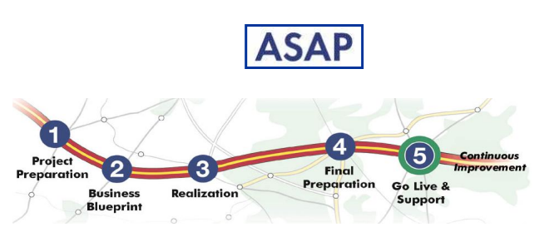
Short form – PBRPS
1.Project Preparation- Initial planning & preparations: Goal, Strategy, implementation sequence, team
2.Business Blueprint- How company intend to run SAP to support their business. The result is the business blueprint, a detailed documentation of the result collected during requirement gathering workshop – AS IS, TO BE, GAP Analysis
3.Realization- Implement all the business process as per business blueprint.
a. Base line configuration- It is the configuration for which, we don‟t depend on other module consultant (it is a configuration which is specific to one module).
b. Final configuration(Integration between Modules): - it is the configuration for which we need to depend on other module consultants(MM,PP,FI). This configuration we can‟t do on our own. Ex- Credit Management, Third party.
4.Final Preparation- Complete the final preparation- Unit testing, Integration testing, user training, cut-over activities. And if any issue is there that need to be resolve.

A legacy system is outdated computing software and/or hardware that is still in use. The system still meets the needs it was originally designed for but doesn't allow for growth.
Cutover: represents the period immediately prior to go-live. It includes the set of activities required to prepare the SAP production system and transition data and processes from the legacy environment to SAP production.
Go live and support:
- Production support
- Monitor system transaction
- Optimize Performance
- Help desk and competency center

VF11 : cancel invoice
VL09: Reverse PGI
VL02n : Delete the delivery

Sales Return:
Sales order-outbound delivery-Billing Document-create sales return-Delivery-credit memo
(Note)(G2)
SAP creates the billing document(credit) from the returns order rather than from the delivery so that the customer can receive the credit without waiting for the goods receipt to take place if, for example, it may take a while for the stock to be returned to the plant, but the customer wants the credit immediately.
Credit Memo:
Sales order-outbound delivery-Billing Document-credit memo request (CR-VA01)-Credit Memo (Note) (VF01)
Sales order-outbound delivery-Billing Document-debit memo request (CR-VA01)-debit Memo (Note) (VF01)
Credit memo: A sales document created on the basis of a customer complaint. This reduces receivables in Financial Accounting. Ex. defective goods or because you have overcharged a customer. Company has to pay to customer.
Debit memo: A sales document created on the basis of a customer complaint. This increases receivables in Financial Accounting. you may need to create a debit memo, if, for example, you have not charged the customer enough. Customer has to pay to company.
Return delivery not required because if the goods are damage and we don’t return it then we can directly raise a credit memo
Define Billing Document Type:
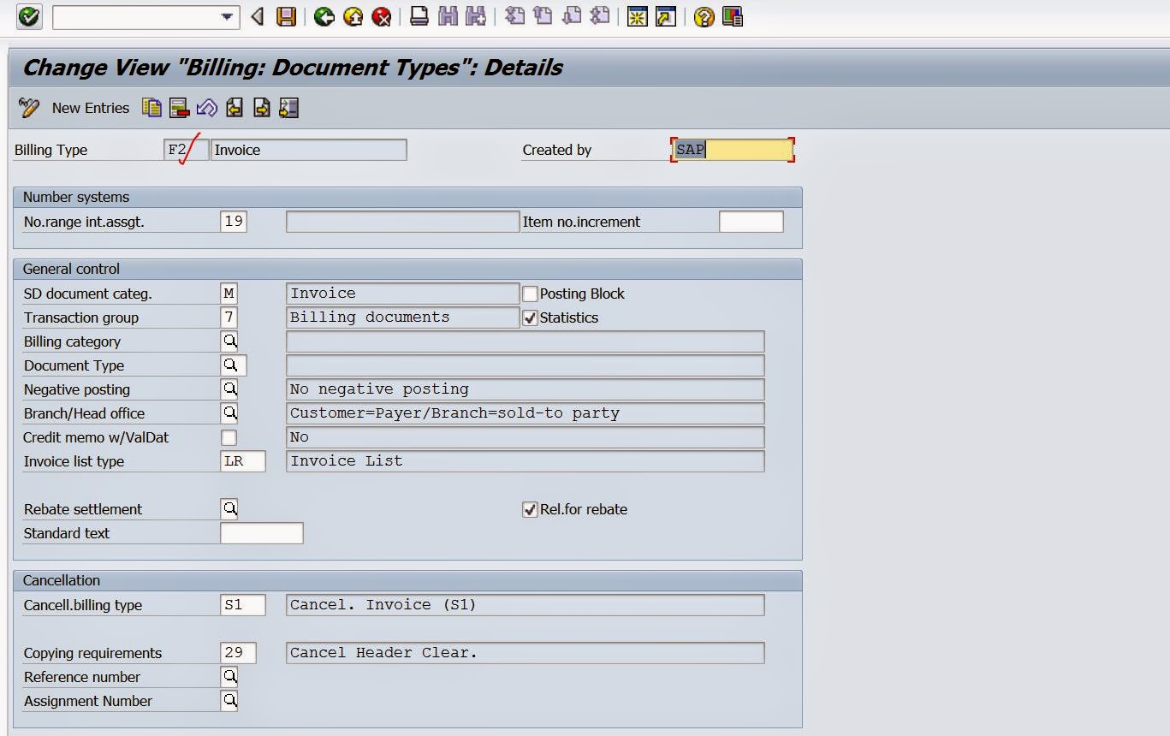
Sales Doc. Cat: A classification for the different types of documents that you can process in the sales and distribution system (for example: P-debit note, O-credit note, M-Invoice).
Order (doc cat) -invoice (billing type)
Billing Category: Used to differentiate the billing documents by requirements for: ex. Invoice printing, billing request, down payment, any settlement document.
Posting Block: To block automatic transfer of the billing document to accounting, mark the field.
To post the invoice into accounting manually go to change mode of invoice and click on release (Flag symbol). The T-code to post collective billing document into accounting is [VFX3].
Statistic: To capture data for Standard Reports, we require to activate Statistic Group
Document type: The document type classifies the accounting documents.DD- customer invoice, D- customer credit note, DF- customer debit note
Negative posting: - This field controls if the billing document values is in negative whether to generate accounting document or not. The indicator can be entered in billing types for credit memos and cancelations.
Relevant for rebate- Indicates whether billing documents of this type are relevant during rebate processing.
Cancellation billing type: cancellation billing document will get create with this billing type.
Invoice List Type: Invoice, credit memo, invoice repair, cancellation of invoice
copying requirement routine- Identifies a copying routine. The routine checks that certain requirements are met when one document is copied into another.ex. Order to invoice
Acc det. Proc.: Acc det procedure by condition type.
Document pricing procedure: - This field is one of the parameter to determine pricing procedure in billing document. Normally pricing will be copied from sales order to invoice, but in some scenarios if we don‟t have sales order then we determine pricing procedure in invoice with the help of this field.
Account determination reconciliation A/c: - Normally when we create invoice for the customer account, system determine reconciliation account from customer master. But the client requirement is reconciliation account should not be determine from customer master, so whatever the procedure mentioned here that will get auto determined.
Delivery Text: Copy text from delivery document.

Account Determination:
- G/L accounts needed for posting sales revenue, sales deductions, and VAT are to be determined automatically when data is transferred from the billing document to FI. The billing details are transferred from SD to FI by means of Revenue Account Determination.
- When processing cash sales, a G/L account must be set in the document for cash settlement
- When using payment cards, you also need to post to differing G/L accounts.

Pre requisites to perform Revenue Account Determination

Account Assignment Group for Customer
Customer account assignment category to identify accounts based on customer account groups. One of the common criteria, for example, is to distinguish the sales of domestic customers from those of international customers. hence we create/maintain groups of accounts and assign them to the customer master records
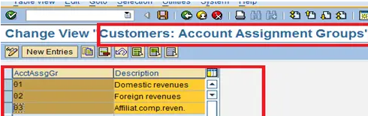

Account Assignment Group for Material
like ways, We need to maintain Master data Relevant for Account Assignment & Assign to material master data
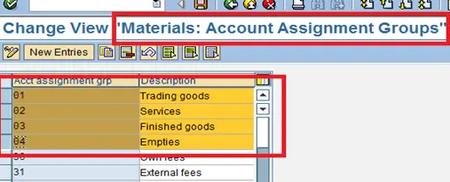
Step to perform Automatic Revenue Account Determination
- Create condition table with key combinations
- Create Access sequence with key combinations
- Create condition type
- Define Account Determination Procedure
- Assign Account Determination Procedure to billing document type
- Define Account keys
- Assign Account keys to Pricing Procedure
- Assign G/L Accounts (VKOA)-condition type,ChAc,sales org,ActKy,G/L Acc

1.Condition Table:
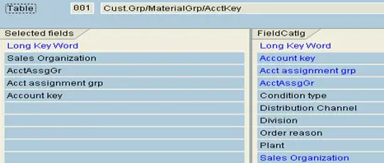

2.Access Sequence:
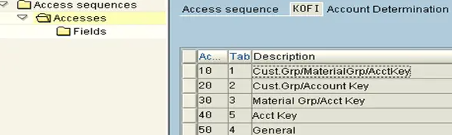
3.Condition Type:
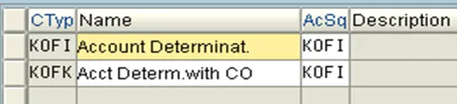

4.Define Account Determination Procedure type:
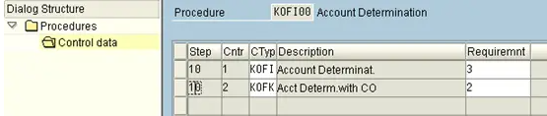
5. Assign Account Determination Procedure to billing document type
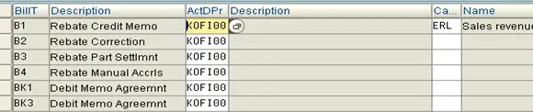

Define and Assign Account keys

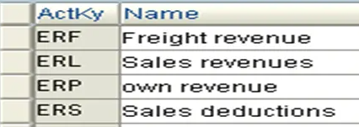
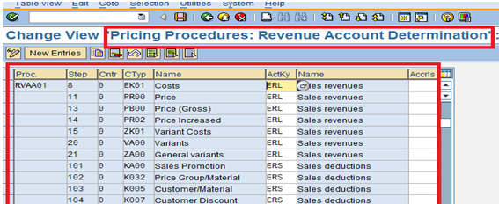

Maintain Account determination procedure in billing document type

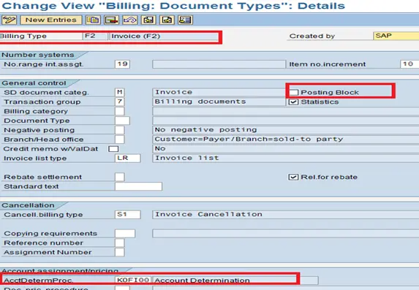

What is GL account? What is account group? What is chart of accounts?
Company is selling laptops to customer. Takes services from vendors and pays rent to building owner.

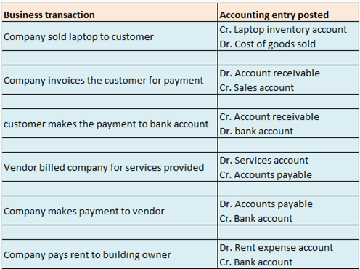
Above picture shows the business activity and corresponding accounting entry to be recorded.
To be able to post above accounting entries, below general ledger accounts need to be set up in the company code.
General ledger for laptop inventory account
General ledger for cost of goods sold
General ledger for accounts receivable
General ledger for sales account
General ledger for bank account
General ledger for service account
General ledger for accounts payable
General ledger for rent expense account

Similarly in practical business scenario there will be various business transactions and in order to record corresponding accounting entry, appropriate general ledger account needs to be set up in company code.
Accounting entry is recorded in sap by posting a document. An accounting document will have few general ledger accounts debited and few general ledger accounts credited (net sum zero hence double entry book keeping).
General ledger account needs to be created prior to accounting document posting.
In sap, general ledger accounts are represented by a number. Each general ledger account will be represented by a unique number.

Below screenshot showing an accounting document which has two general ledgers account posted
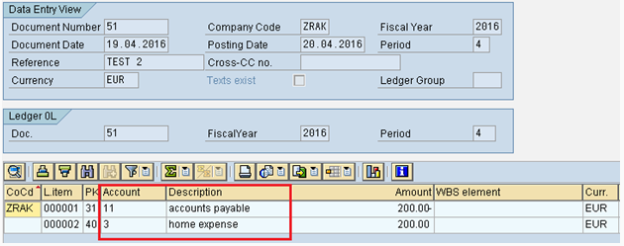
General ledge for accounts payable is represented by number 11
General ledge for home expenses is represented by number 3
A company might have thousands of different accounts in their book of accounts. Hence thousands of general ledgers need to be created in sap. General ledger of similar nature is grouped together and is called as account group.
All account groups put together is called chart of accounts.
As the name suggests, chart of accounts is the list of all the accounts put together.
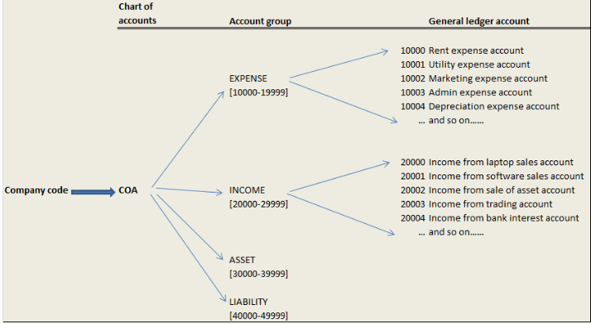
Company is assigned chart of accounts.
Account groups are created under chart of accounts.
General ledger accounts are created under account group.

Each account group is assigned a number range. General ledger account when created under an account group has to be within account group’s number range.

Partner Determination Procedure: VOPAN
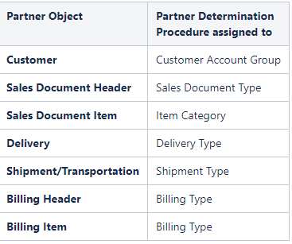
1.Define Partner Function:
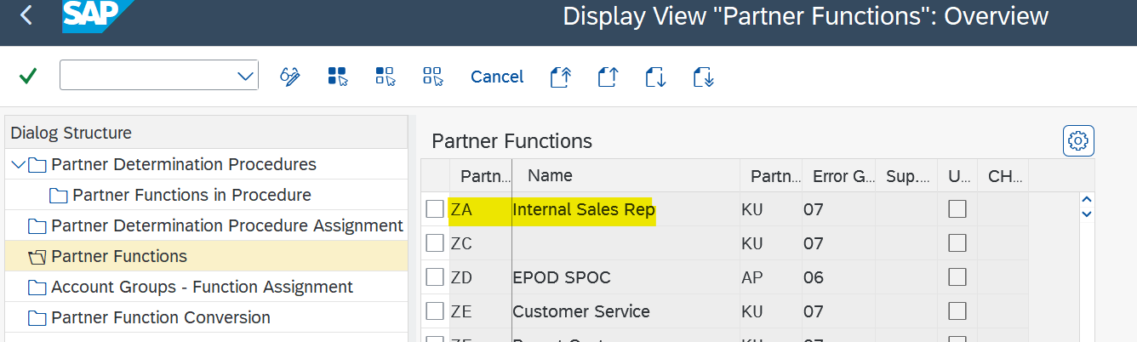
2.Assign partner function to customer account group:
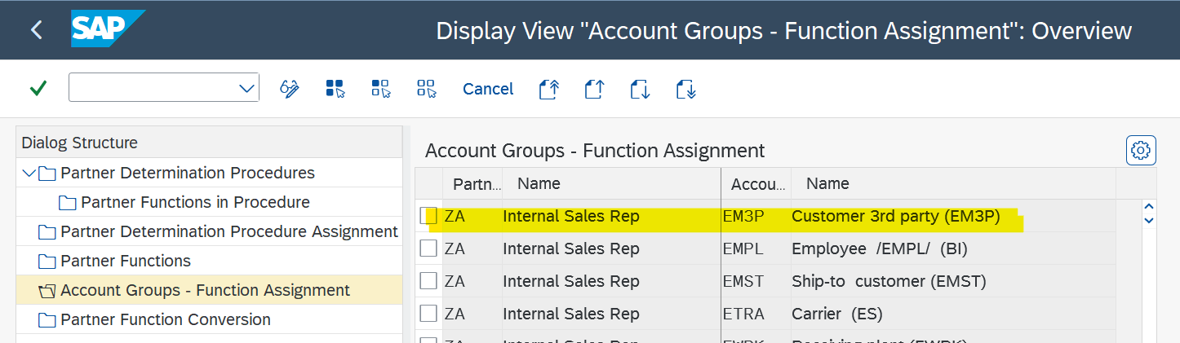
3.Define Partner Determination Procedure:
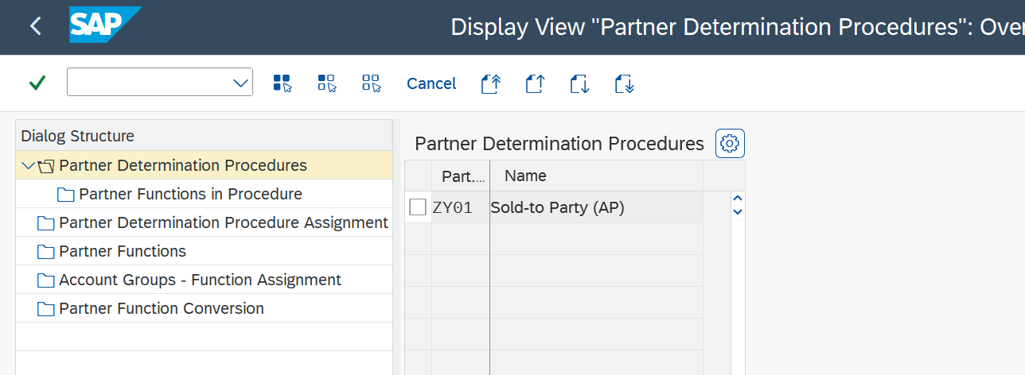
4. Assign partner Determination Procedure to Customer account Group
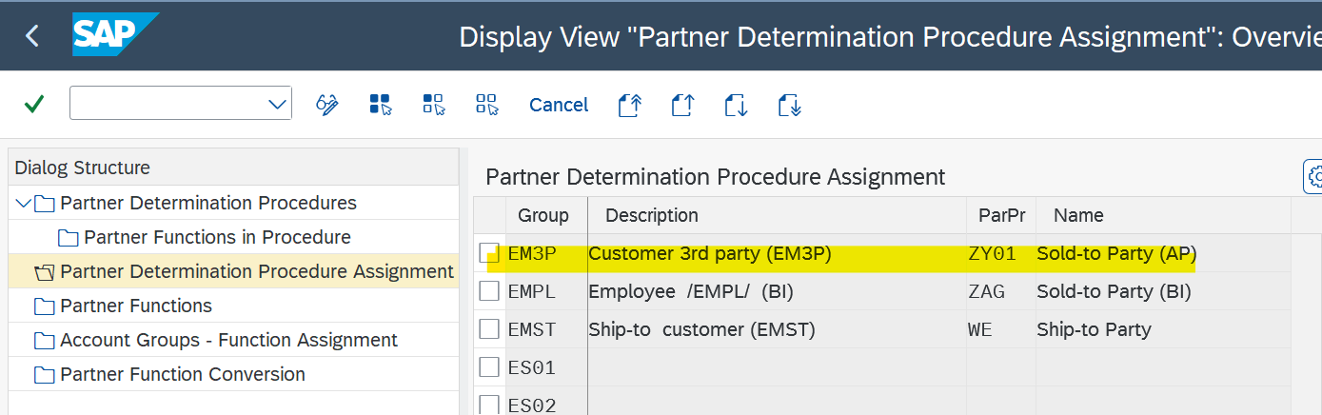

5.Assign Partner Function in Procedure (function to Procedure)
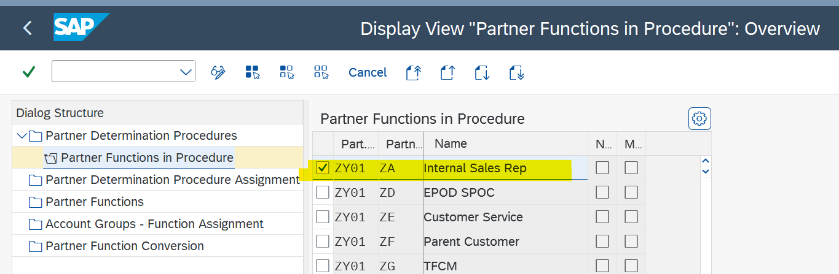
Customer Account Group:
Customer Account Groups in SAP are used to determine:

- The number range interval for customer accounts
- It determines the type of number assignment, whether the number is assigned internally by the system or externally by the user.
- Whether it is a onetime account
- Account group determines which field are mandatory or optional when creating or changing customer master data.

- You can change the account group (XD07) for the following partner functions:
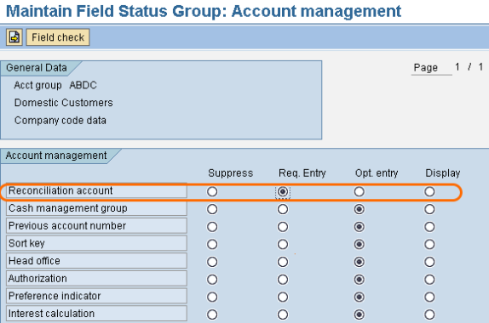
Field Status: Under field status you can choose the option as suppress, required entry, optional entry and display.
General Data: Update the options for Address, Communication, Marketing, Payment Transactions, Contact person, foreign trade, etc.
Sales Data: Update the required details as display or required or optional entry for sales data.
Combine multiple orders in single delivery:
a) The ship-to-party of all sales orders must be the same.
b) The delivery date of all the sales orders must be the same.
c) The shipping point of all the sales orders must be the same
d) Incoterms : An international commercial term (Incoterm) defines the terms of sale and the passing of risks for import and export of merchandise. DDP: delivered duty paid, FPB: Free on board, CIF: cost insurance fright
e) Route
If all the conditions satisfy then use tcode VL10A to see the list of ales orders due fro delivery select all the sales orders click on background button then system eill give group no select that no go to details button then click on edit specify pick qty the click on post goods issue .This way single delivery created for multiple sales orders.
Combine multiple deliveries in single Invoice:
To combine multiple Deliveries into one invoice, your Deliveries shpuld have same
Payer
Payment Term
Billing date
In Copy Control (VTFL) at Item level, in the VBRK/VBRP field, Routine 001 or 007 must have been assigned for Collective Invoice.
Material Listing/Exclusion:
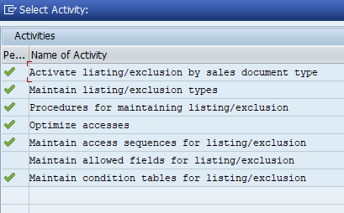
Condition Table- Access Table- Assign condition table to access sequence-listing exclusion type-listing/exclusion procedure
Condition table:
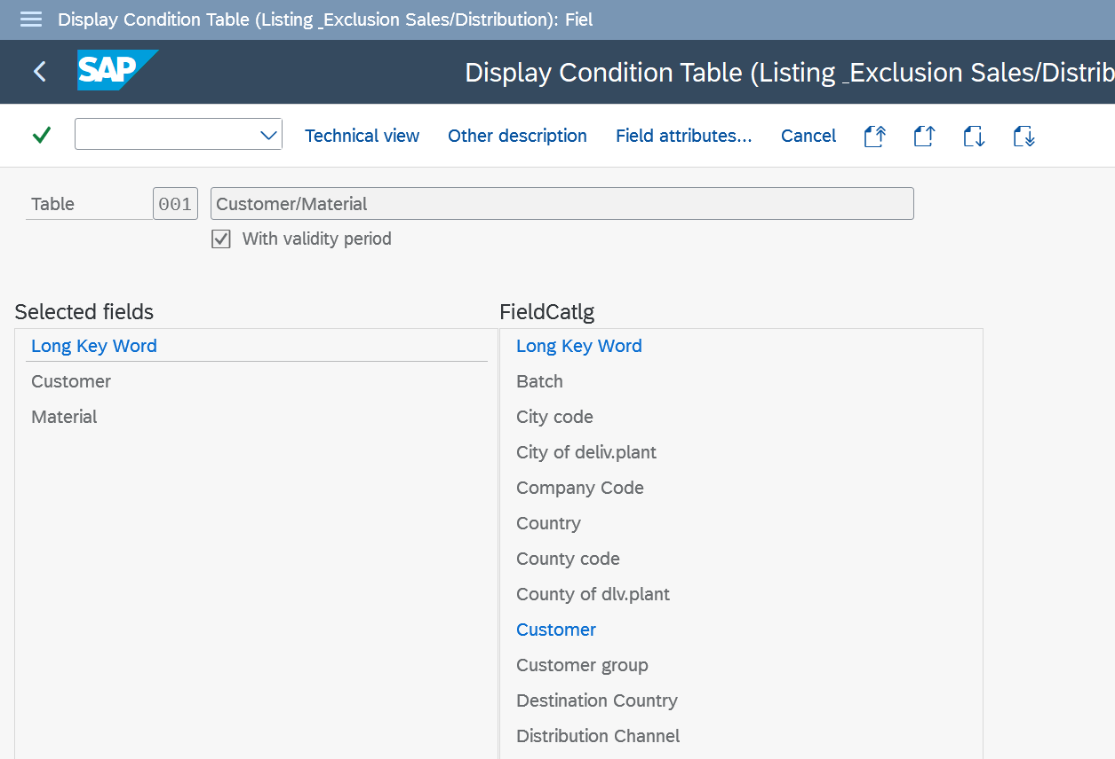
Access sequence:
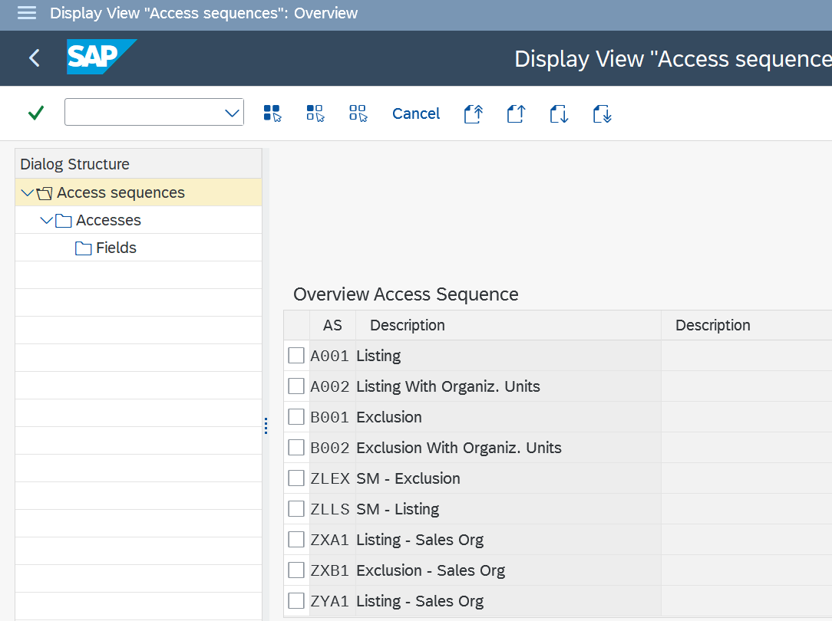
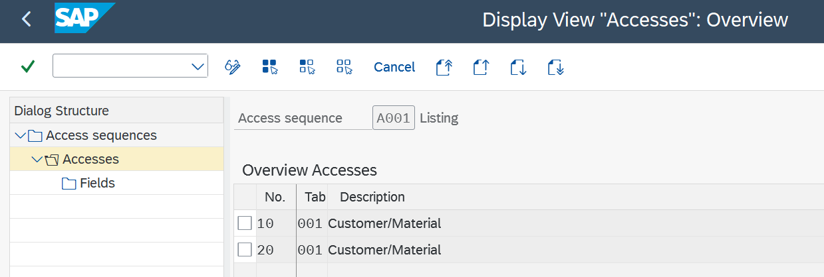
Define condition type and assign to access sequence:
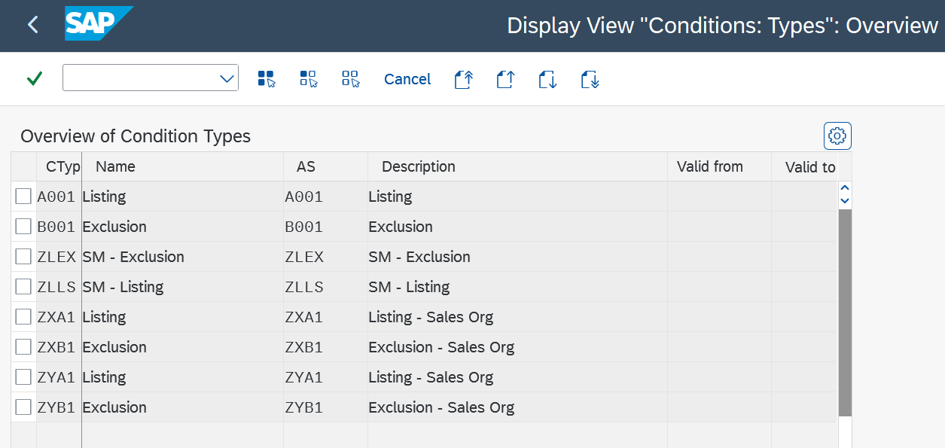
Define Procedure for listing/exclusion:
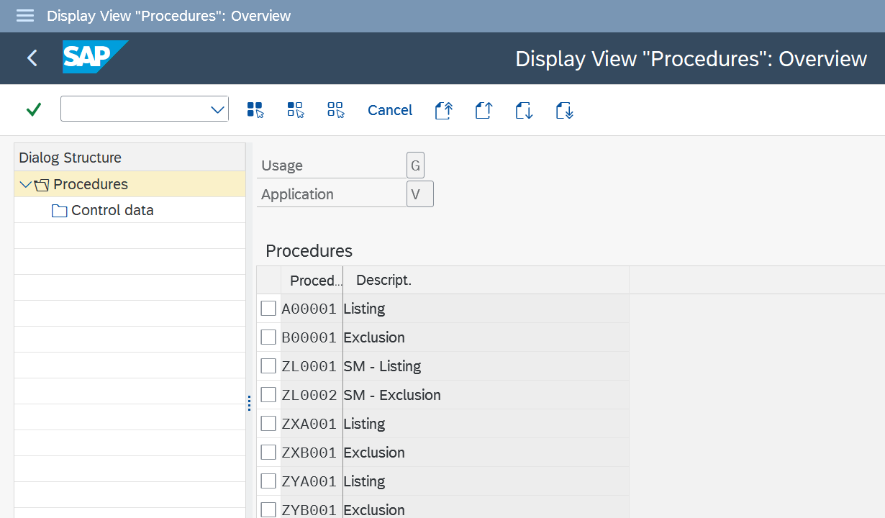
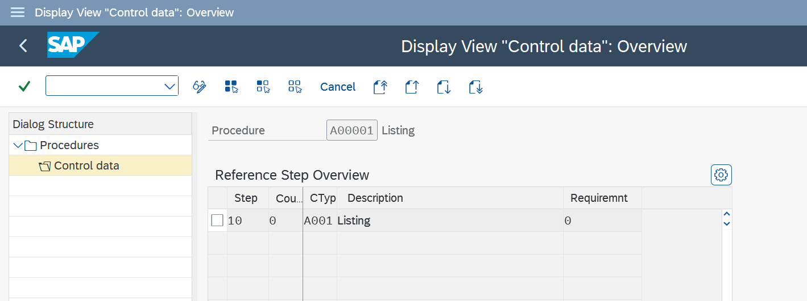
Activate listing/exclusion by sales document type:
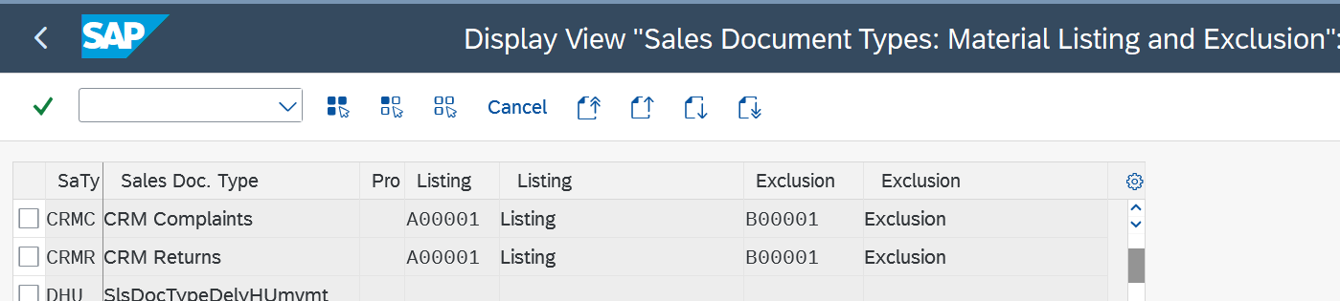
Condition record transaction : VB01, Exclusion type: B001, Listing: A001
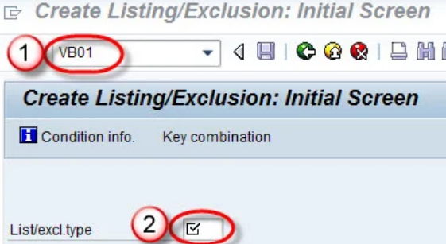
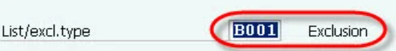
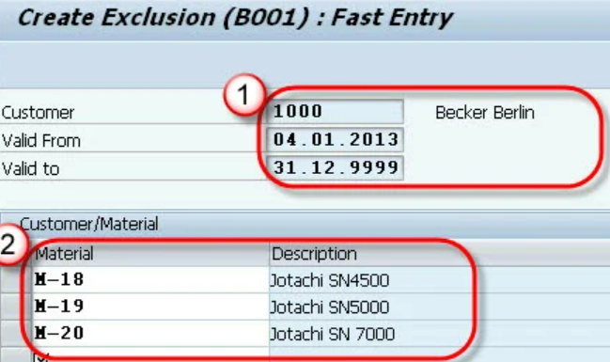
When a user create sales order by t-code VA01 ,for material M-18 ,for customer # 1000 , a message “Material M-18 has been excluded” displayed.
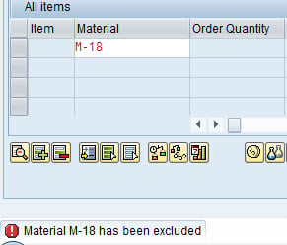
Similarly for listing.
Sales doc type- procedure-listing/exclusion type-condition record maintain VB02
Free Goods Determination:
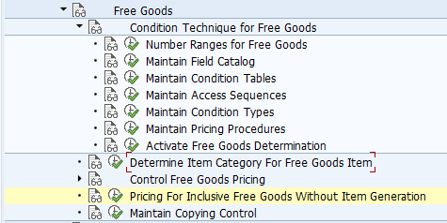
Field Catalog:
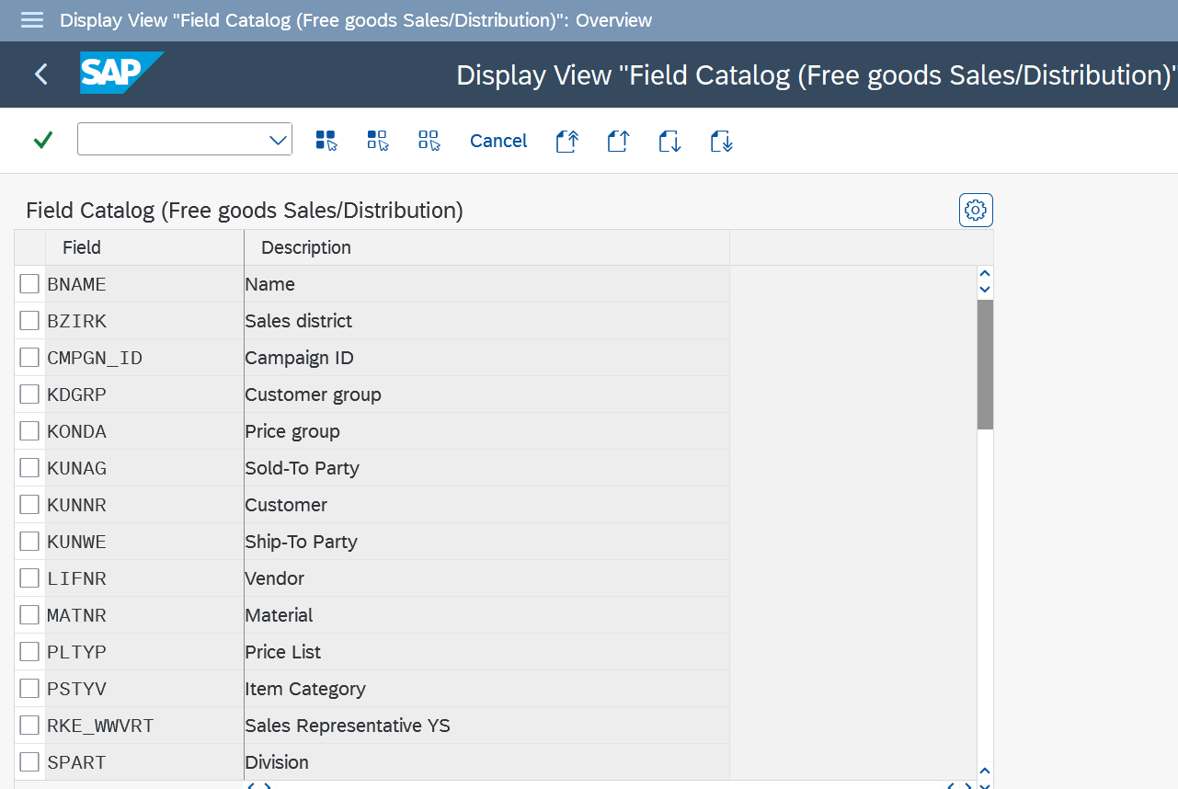
Condition table:
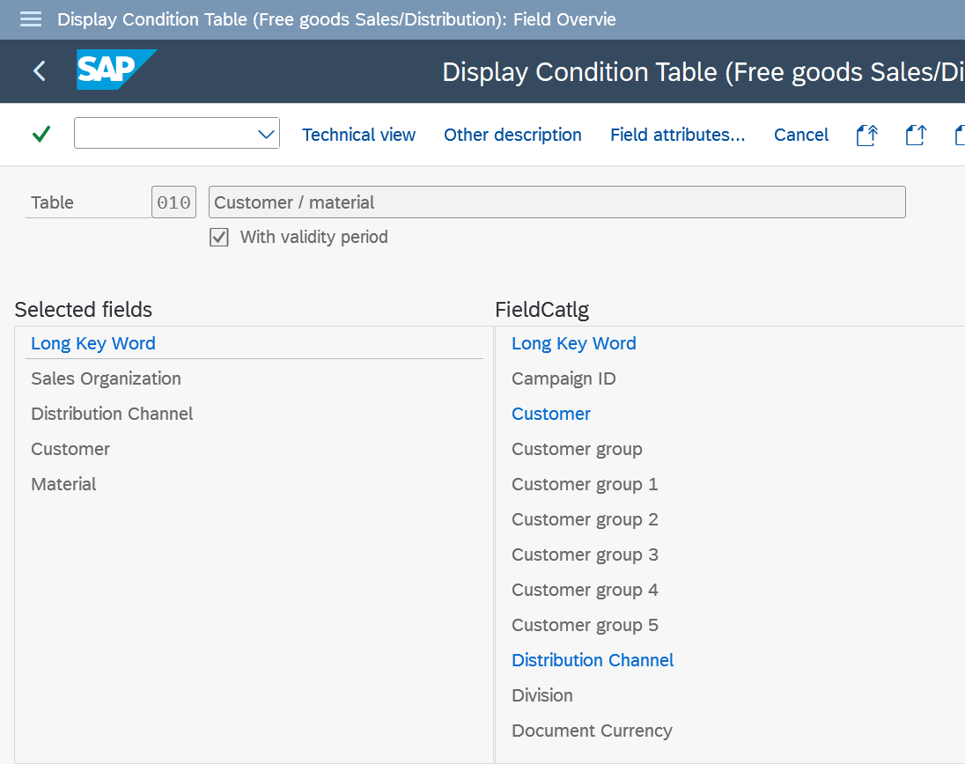
Access sequence:
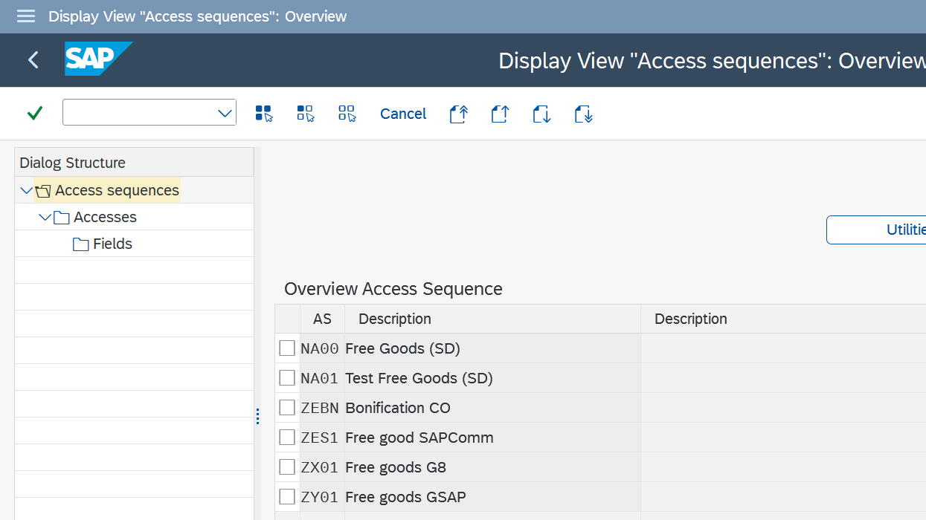
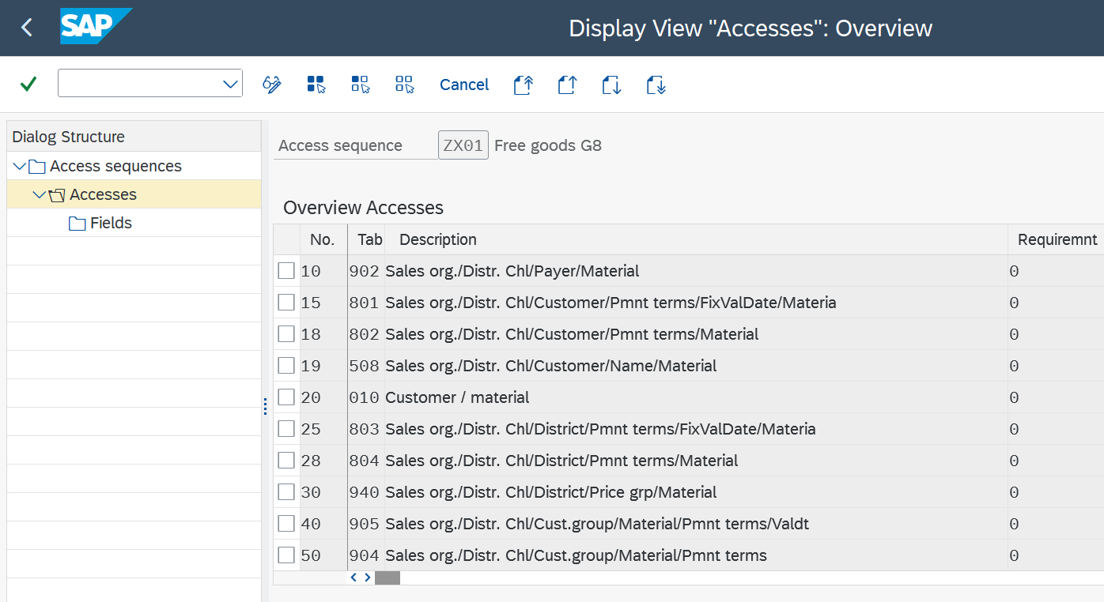
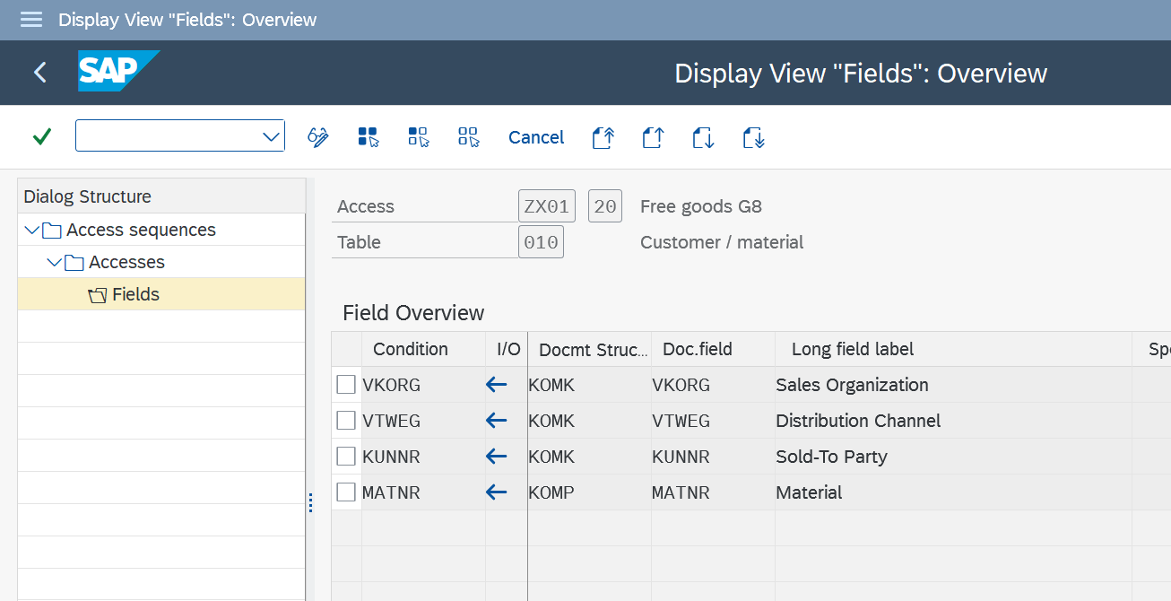
Condition type:
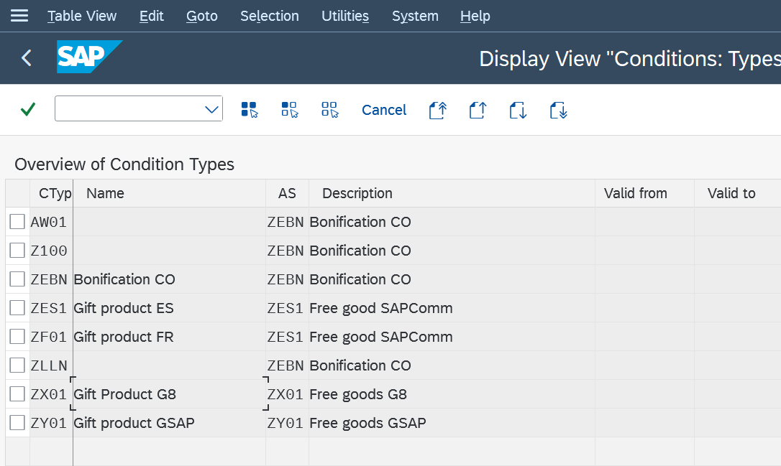
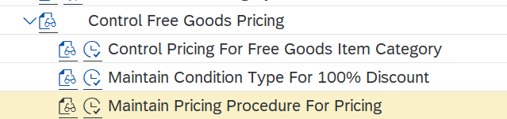
Maintain pricing procedure
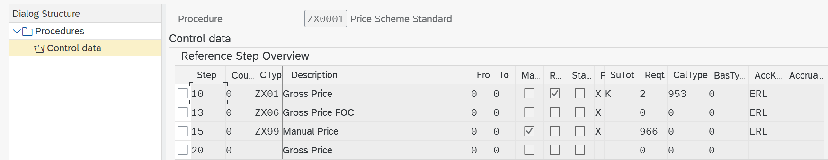
Activate Free goods determination – Define pricing procedure for free goods determination
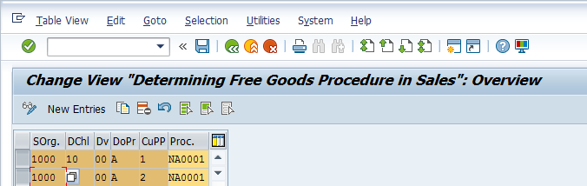
Sales area-doc. Pricing procedure-customer pricing proc-Free goods pricing procedure
Control free goods pricing- for item category define pricing
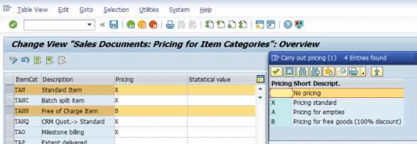
Condition table-access sequence-assign condition table to access sequence-condition type-free goods pricing procedure- condition record (NA00)
Transaction condition record: VBN1
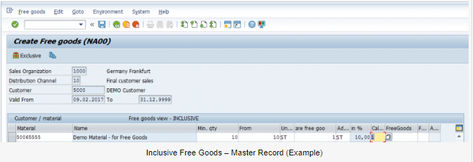

Automatic Send mail when sales order is change
Write the codes in sales order userexit program so that as soon as you save the sales order the email can be triggered.
Abap Program: MV45AFZZ
USEREXIT_SAVE_DOCUMENT
Add email address in hard code only
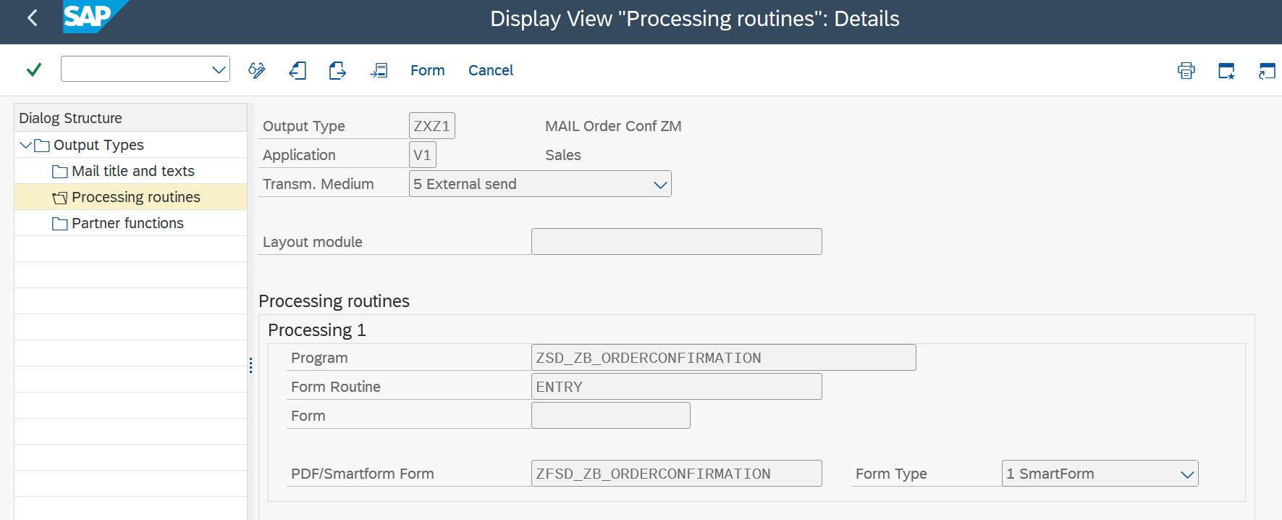
Output type- medium 7 simple mail

Program (driver program)- extract the data from database table and passes it to smartform.
Ex. Let say, user want to print the customer name on form, driver program fetch it from R3 database and pass it to smartform and it will get print on required place
Routine- will check the condition to be satisfy to trigger the output type. Like sales order should be complete, no credit block, qty should be confirmed.
Smartform- Layout on which the details will get printed. Tcode- Smartforms.
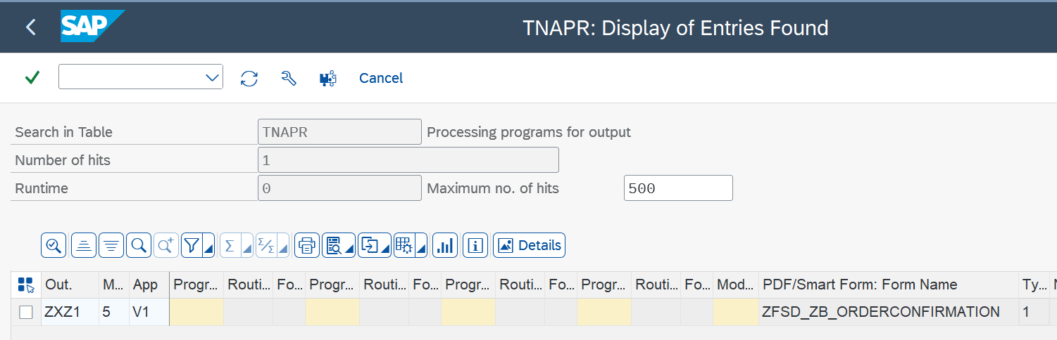
Object key- Sales order no.(delivery, invoice), msg – output type, Partner- to whom output get sent, Role- type of partner.
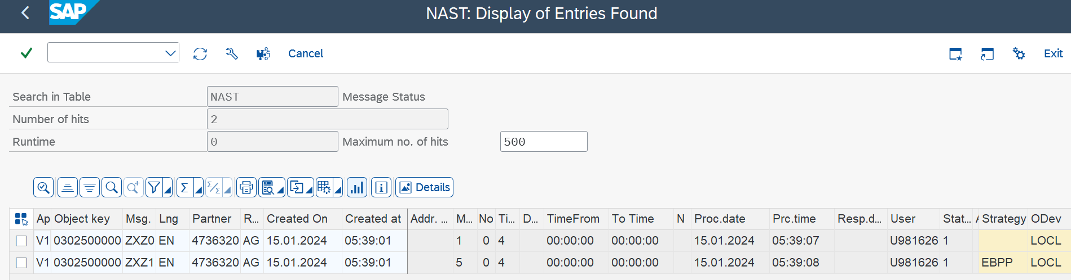
Tcode- SO10- Standard text define here.
Nace- Output control
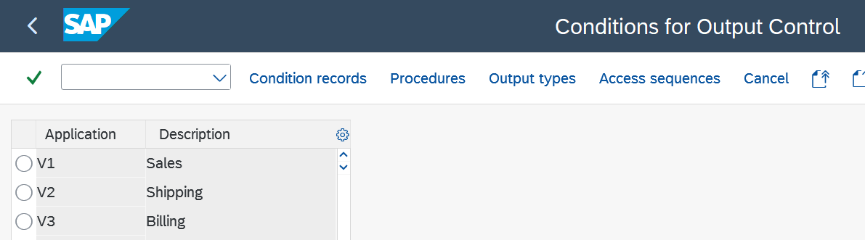

Send delivery note (PDF) on email

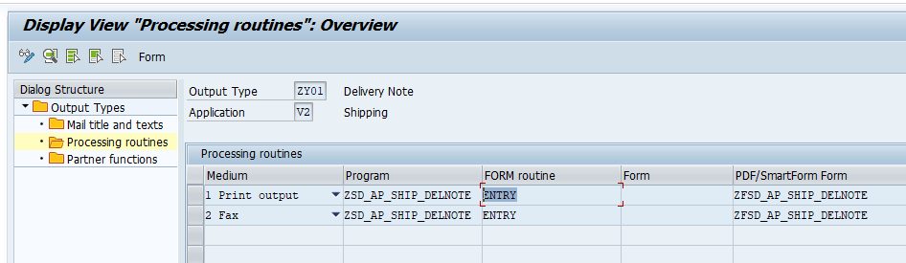

RFC: Remote function call

It calls the function module from SAP system and enable the interface between SAP to Non-SAP system.

Order gets created in the portal. Then RFC calls the functional module from SAP system and reflect that order in the SAP system.

IDOC:

The transfer from SAP to non-SAP system is done via EDI (Electronic Data Interchange) subsystems whereas for transfer between two SAP systems, ALE is used.
IDoc can be triggered in SAP system or in EDI subsystem. This depends on the direction in which IDoc is sent and is called as Inbound IDoc and Outbound IDoc accordingly. In case of outbound flow, IDoc is triggered in SAP through document message control which is then sent to EDI subsystem. EDI converts the data from IDoc into XML or equivalent format and then sends the data to partner system through Internet.
For inbound flow, EDI converts partner data and IDoc is created in SAP. After successful processing of this IDoc, Application Document is posted in SAP.
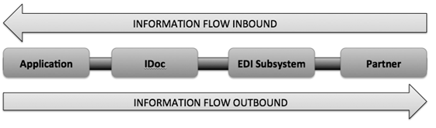

CONTROL RECORD (EDIDC)

It contains information such as IDoc number, direction, IDoc Status, Basic Type, Message Type, Partner (Sender/Receiver), date and time of creation/update, Interchange File or ISA number,etc

DATA RECORD (EDID4)

It contains the details of the IDoc segments.

STATUS RECORDS (EDIDS)

IDoc Status defines the processing status of the IDoc. IDoc statuses are used to track the IDoc and its various processing states. Status Numbers represents IDoc status. Current status of the IDoc is present in Control record.

Initial Status numbers are 64 for inbound and 03 for outbound. Successful status is 53 for inbound and 16 for outbound IDocs.

Failed status for inbound 51 and for outbound IDoc 12

IDOC (BASIC) TYPE

Basic Types (or IDoc Type) defines the structure of an IDoc. Each basic type describes standard IDoc segments, format of data fields and their size. Basic Type also defines number of segments and fields in an IDoc. All the fields that are necessary for transmission of message for a particular business transaction are mapped in different segments.

IDOC EXTENSION
Basic type contains all the standard fields that are necessary for carrying out a business transaction. However, if any additional values are to be sent to the partner then we can make use of the IDoc Extension feature. IDoc extension is extension of basic type and contains additional custom IDoc segments and fields that are not available in standard basic type.

IDOC SEGMENTS
IDoc segments contain the actual data that is sent to or received from a partner. These segments contain the actual values that are sent as part of IDoc transmission.

PARENT AND CHILD SEGMENTS
IDoc segment is termed as Parent segment if it contains its own segments. The dependent segments are called as child segments.

PARTNER TYPE
Partner type/role is used to identify partners within the sap systems. Partner type is KU for customer, LI for vendor and LS for Logical System.

MESSAGE TYPE
IDoc processing involves transmission or receipt of document in the form of a message, each of which represents a document in SAP. These documents can be Order, Shipment Confirmation, Advance Shipping Notification, Goods Receipt, or Invoice. Message type is associated with Basic IDoc Type (Basic Type) and defines the kind of data or document that is exchanged with the partner.

PROCESS CODE
The process code contains the details of the Function Module that are used for IDoc processing. Message Type can be linked to the Process code.

PORT
IDoc Port contains the information about the way data is sent between the source or target system. The type of port defines the information contained within the port. For port type “Internet” Port will contain IP address of the target system. For port type “file”, directory or file name information is maintained. “tRFC” port contains information about the RFC destination of the target system. For IDoc transmission using ALE “tRFC” ports are used.

PARTNER PROFILE (WE20)
Partner profile must be maintained for all the business partners to whom we want to send or receive the IDocs. The TCODE for maintaining the partner profile is WE20.

Partner profile contains parameters for Inbound and Outbound processing of IDocs. For each message type we can maintain, inbound/outbound options, message control, post processing options and contact information within Inbound and outbound parameters.

Change Message Indicator indicates whether the IDoc is sent a notification of change. For example, Purchase Order change messages are sent to vendor using EDI standard message type 860.

Separate message type should be triggered in the purchase order for PO change. Additional line with change message type must be added in the Message control tab with change message indicator on.

POST PROCESSING (INBOUND/OUTBOUND PARAMETERS)
In the post processing option we can maintain the workflow details of the users or positions to which an error notification will be sent if an IDoc processing fails.
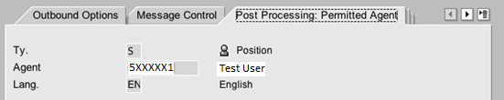
Usage of price group in customer master
Say you have 2 customers and 2 customers have 2 pricing groups. Customer A belongs to Wholesale Pricing grp and Customer B belongs to Retail Pricing grp. Maintain a condition record With the help of the Customer / Pricing grp key combination. Now for wholesale you give extra discount and for retail you give less discount. Now when you create the sales order with Customer A then he will be getting extra discount But if you create the sales order with Customer B then he will be getting normal discount
Price group is a field where you can group certain customers under one umbrella.
Suppose if you have 3 price groups say price group1 price group2 and price group3.
Say there are 10 customers A to J.
- You are assigning customers A to D in price group 1.
- You are assigning customers E to G in price group 2.
- You are assigning customers H to J in price group 3 in their respective CMRs.
Price group can be added as filed in pricing condition table and you can maintain condition records for them:
In VK11 the table with price group 1 is maintained discount of 5 %
In VK11 the table with price group 2 is maintained discount of 6 %
In VK11 the table with price group 3 is maintained discount of 7 %
So in sales order the customers A to D will get 5 % discount and customers E to G will get 6 % discount and customers H to J will get 7 % discount.
Item Proposal: - If customer is regularly placing order for similar items then instead of entering the items manually into sales document every time, we prepare a list and call the list while creating a sales order. The end user will select the items from the list and copied into sales order which will save the time of end users. The T-code for creating item proposal is T.CodeVA51. Mention the item proposal as PV Maintain sales area enter description mention material and Tgt quantity, UOM, Description and save it. Go to the item proposal to customer master and assign the number and save it.
Price list: - Grouping of customers who will share the same base price. Price list will be used to maintain base price. Ex. Dealer pricelist, Distribute pricelist,
Cash Sale:
- Customer picks and pays for the goods immediately after the order.
- The delivery is automatically created upon saving the Sales order.
- An invoice printout obtained immediately from the order and given to the customer. However, the actual billing process is carried out later.
- The Delivery may or may not be relevant for picking. In case the delivery is not relevant for picking, goods issue happens
automatically in the background so that invoice can be created.
- No accounts receivable posting from the billing document. Invoice amount is directly posted to cash account.
Rush order:
- Customer places order and collects the goods item immediately
- Invoicing is done later
- System creates automatic delivery when the sales order is saved
- Once the goods are removed from storage, the goods are picked, and goods issue is posted
- The billing is delivery-related, and similar to that for Standard Order
- Only difference between Standard order and Rush Order is that in a Rush order, the delivery is created immediately.
However logistic process of picking, packing and goods issue processing would still need to be carried out
- block the customer for a particular sales area or for all the sales areas. Vd05
- Material block for sales org, dist channel, plant : MM06
- Fright conditions- Incoterms. Tax- Departure country/destination country, domestic or export.

Rebate Process
Rebate is a discount, but it does not give immediately right after the transaction it start accumulating the values and given on pre-determined time.
Credit card- Retail customer is using a credit card more you sped more you get the points. City bank will give the choices like redeem them for products, for money, voucher. Ex. Rewards, loyalty points
B2B- Farmer will sell the vegetables to certain type of supermarket and farmer may give reward points to them as supermarket is purchasing from that farm.
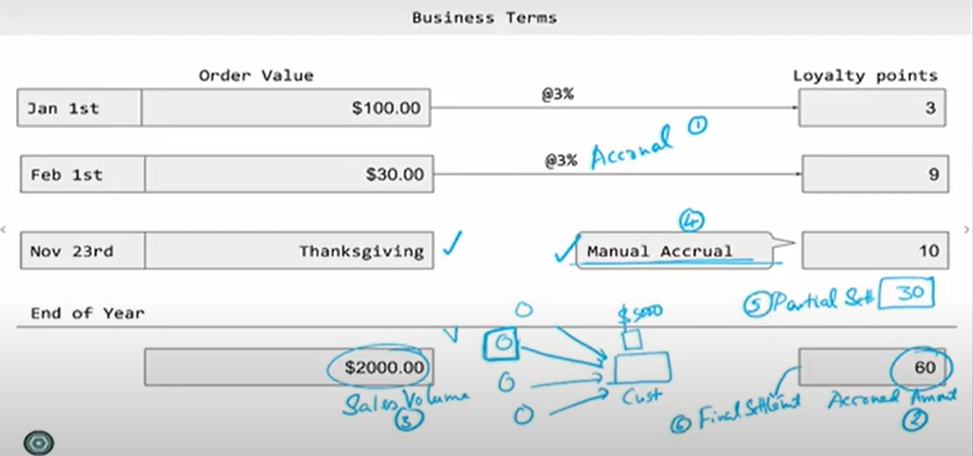
Accrual- Company will set up certain amount of money or points in separate amount called as Accrual. It’s a per transaction amount.
Accrued Amount- Total of accrual amount.
Manual Accrual - - ex. Car sales- if vendor sell at least 100 cars in month of particular model this is the deal with car company let’s say Honda then on top of his regular accrual company will give 5000 dollar as a additional bonus.
Partial settlement- Settle the amount in middle of the period.
Final Settlement - Settle the amount after completing the target or period.

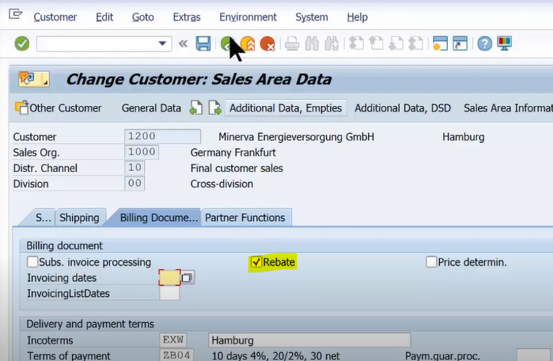
Activate the rebate to Payer

Create Agreement
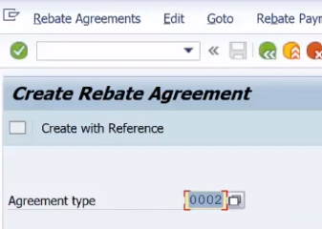
Enter heighted details. Validity period came from agreement type
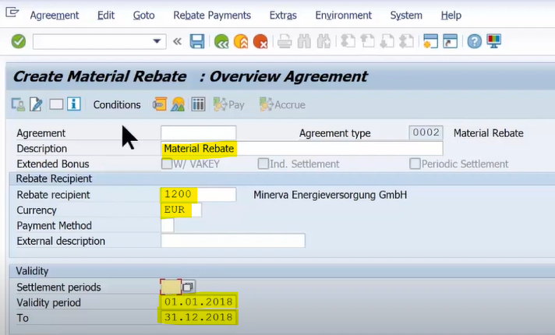
Click on condition- select required one and maintained a record.
Here 1PC= 100 EUR
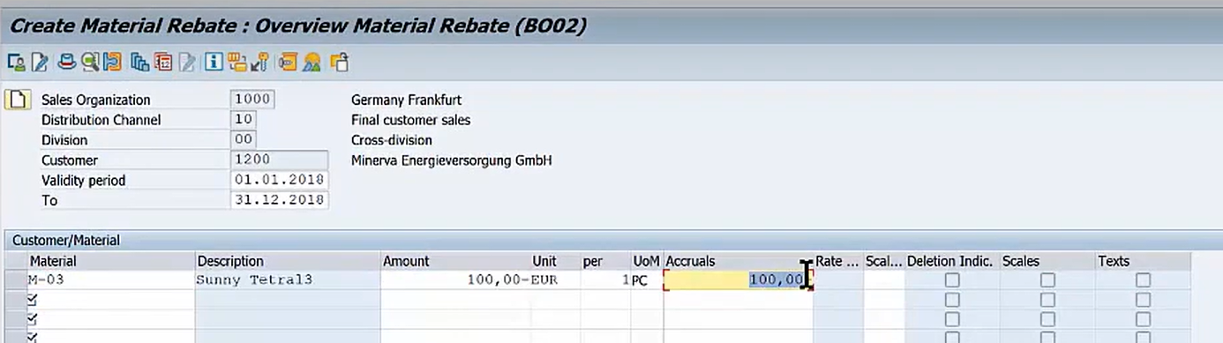
Create order- delivery- invoice.
As per condition record on purchase of 100PC accrual is 10K EUR. It’s a statistic amount hence it will not affect on Net amount.
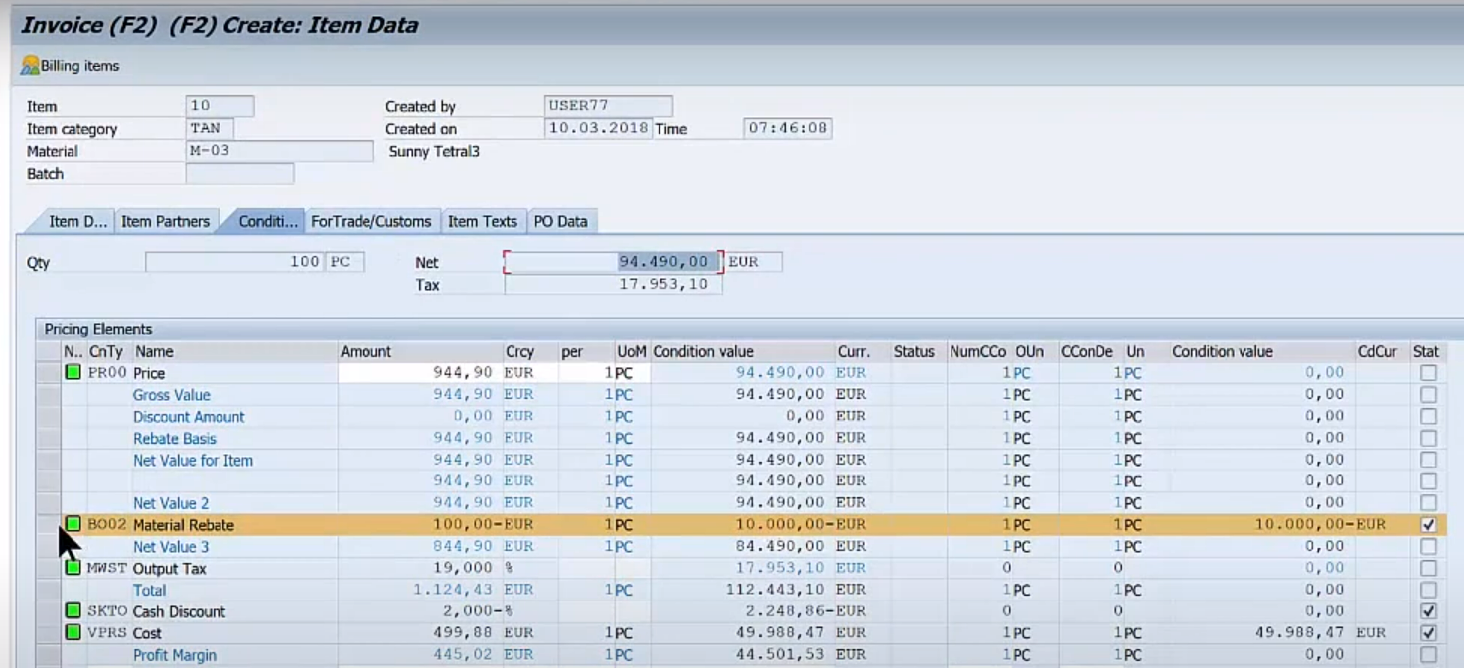

Amount get accrued in certain account.
Rebate accrual- accruing the amount for customer. The amount is not paid yet.
Reserve for other- Company might pay to customer or might not its depend on the terms and condition of rebate agreement. After customer hot the target company liable to pay to customer.
This is how rebate condition type hits the GL account.

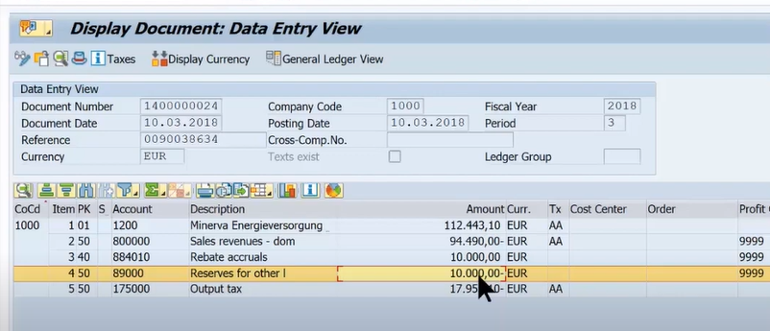
MM Flow
